Modification-free extensibility for existing apps
Exercises
PUBLIC


Table of ContentS

Prerequisites: Access the existing app 4
Adding a button to a smart table 15
Adding a Dimension Filter 22
Adding a map to show the supplier location 23
Related material 24

Summary
You will learn
- How to use adaption projects to create app variants.
- What to keep in mind when you disable the safe mode.
- How to create fragments and controllers.

Prerequisites: Access the existing app

Summary

UI5 Air Cargo has bought the Manage Products application that resides in the ES5 SAP Gateway demo system. This application allows users to search for products and look at the details of those products. This application was created using the SAP Fiori elements list report and object page.

Preview
In this exercise you will configure a trial account on SAP Cloud Platform, SAP Web IDE and you will get a user to access the existing app and our configure the necessary steps in SAP Cloud Cockpit.

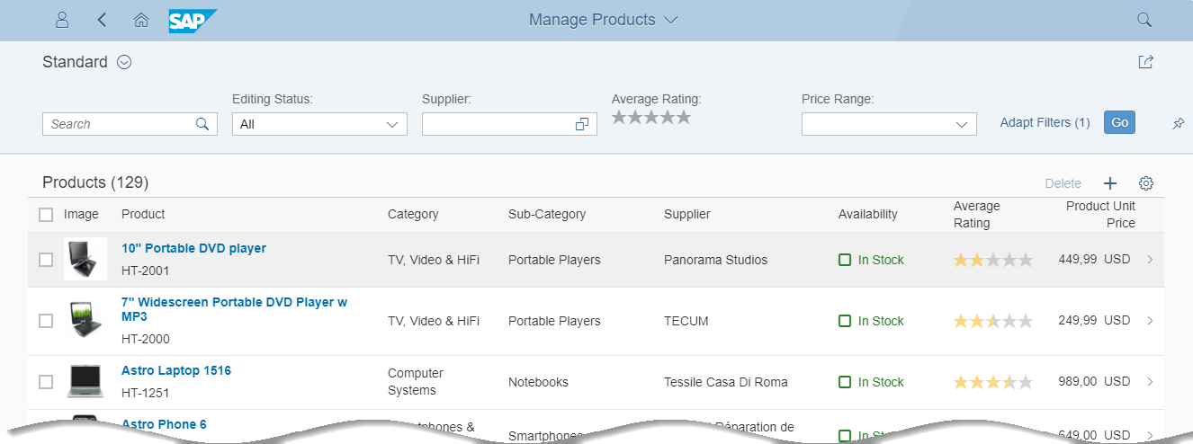
Figure 1 – Manage Products app

Create an SAP Cloud Platform Developer Account

Explanation | Screenshot
- Open your browser, and open the following URL:  https://account.hanatrial.ondemand.com/  Note: Use Google Chrome  We recommend that you use Google Chrome as a browser for this course, as it has the best developer tools. Our instructions and browser-related tips throughout this course will be refer to Google Chrome.  If you don’t have it installed yet, go to the following URL, and follow the setup steps:  https://www.google.de/chrome/browser/desktop/ | 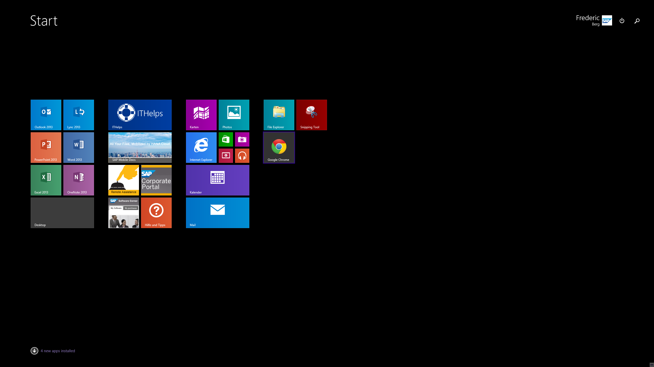
- Choose Register to create a free SAP Cloud Platform developer account. | 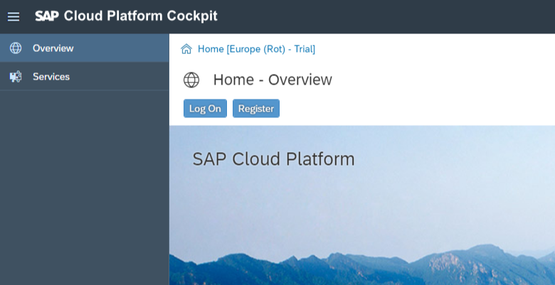
- Enter your name and e-mail address, and choose a password (at least 8 characters long, including upper- and lowercase letters, numbers and symbols).  - Accept the terms & conditions, and click Register.  Note: Trial Account  This will create a developer account on SAP Cloud Platform for you with a free and perpetual developer license. You can use this account to test out the platform or run demo scenarios. | 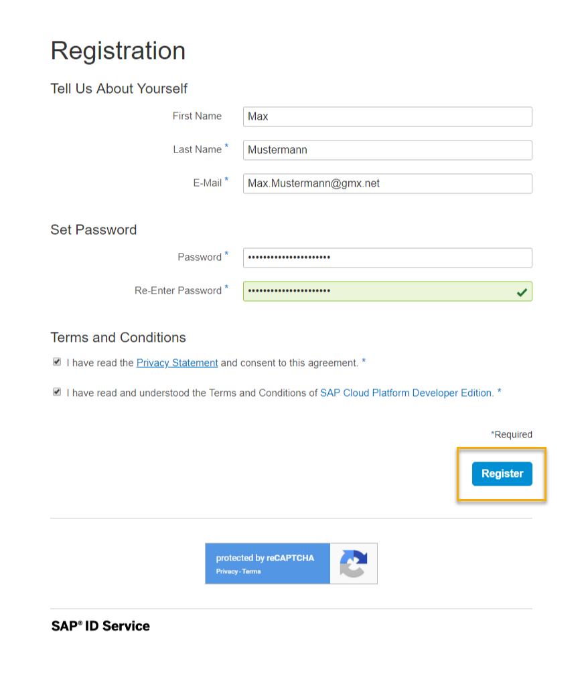
- A confirmation e-mail has been sent to your account. Open it, and choose Click here to activate your account. | 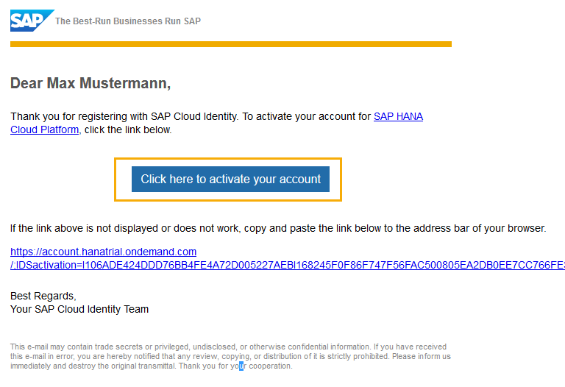
- You should see a confirmation dialog. Choose Continue to go to the SAP Cloud Platform Cockpit. | 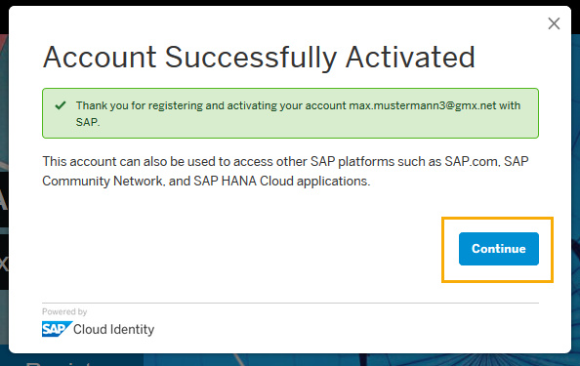
- Choose Neo Trial. | 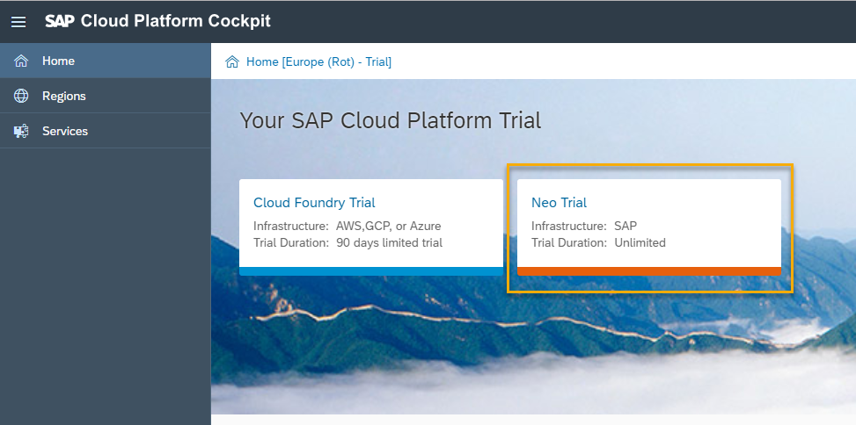
- In the Neo Trial environment, you can see a navigation frame on the left. This is your entry point for managing cloud apps and configurations.  Note: How to keep track of your user  Two sets of users and passwords are created in this unit:  - For the SAP Cloud Platform Developer Account (what we just did)  - For the SAP Gateway Demo System ES5 (later in this unit)  If you are in doubt what your user is do this:  - SAP Cloud Platform Developer Account: On the top right side of the Cloud Platform Cockpit you can display your user.  - SAP Gateway Demo System ES5: You’ll receive an e-mail with the temporary password. This you have to change immediately, of course, but the user will remain the same. | 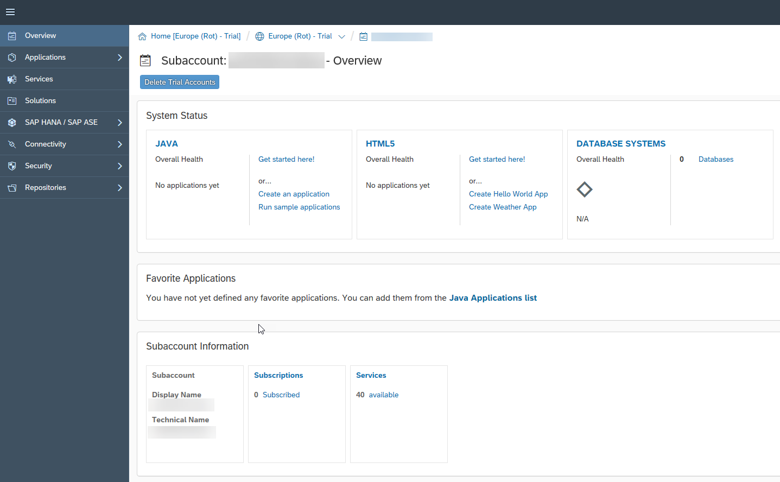  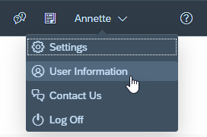  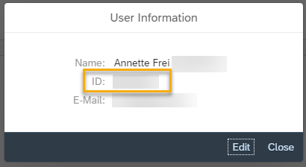

Navigate to Your SAP Web IDE Workspace

In this step, you’ll navigate to your workspace in SAP Web IDE.

Explanation | Screenshot
- On SAP Cloud Platform Home Page, you can directly navigate to the SAP Web IDE. | 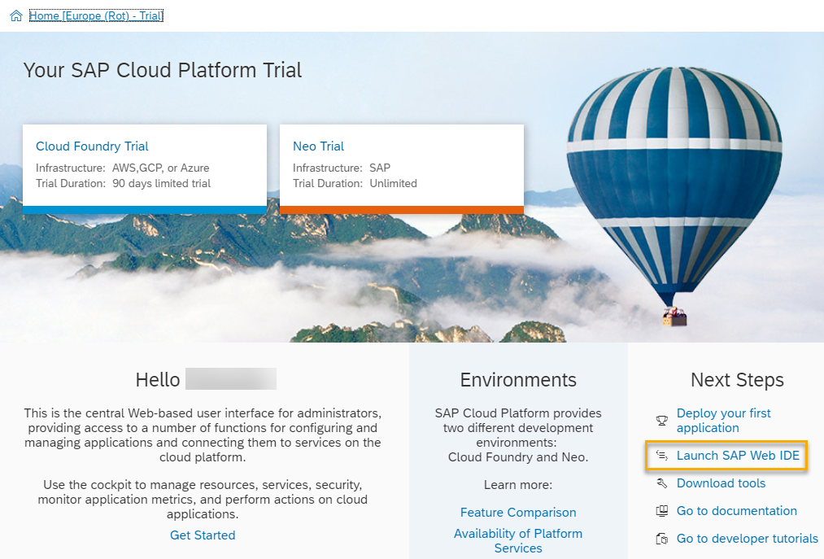
- SAP Web IDE opens. Have a look at the start page. It contains useful links and shortcuts to the most important actions. Choose Open my workspace.  The direct link to SAP Web IDE is https://webidecp-p[XXXXXXXXXX]trial.dispatcher.hanatrial.ondemand.com/  Note: Replace [XXXXXXXXXX] with your trial account user ID. If you are using an existing trial account, you will see a workspace with your other projects in this step. | 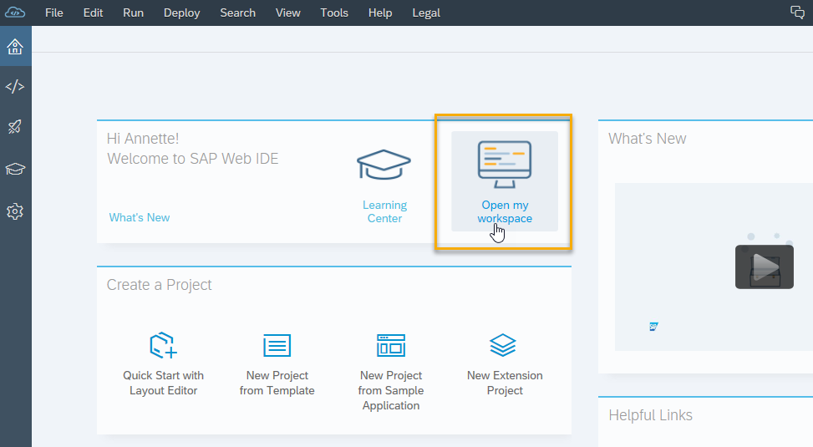
- (Optional) Add a bookmark to SAP Web IDE Full-Stack by pressing CTRL+D in Google Chrome. You will need this link to your development environment frequently throughout the course, so you should bookmark the page. | 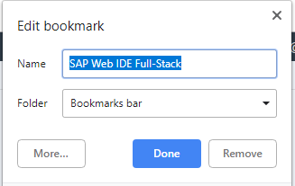

Sign Up and Get Started with the SAP Gateway Demo Consumption System

Explanation | Screenshot
- Start the SAP Gateway demo system with this URL https://register.sapdevcenter.com/SUPSignForms/  - If you see the log on screen, log on to your SAP Cloud Platform account. If you are already logged in you’ll see the SAP Gateway Demo Server welcome page.  - Read the terms and conditions, and choose Register.  Note: How to keep track of your user  Two sets of users and passwords are created in this unit:  - For the SAP Cloud Platform Developer Account (what we did as first step)  - For the SAP Gateway Demo System ES5 (what we’re doing here)  If you are in doubt what your user is do this:  - SAP Cloud Platform Developer Account: On the top right side of the Cloud Platform Cockpit you can display your user (see above).  - SAP Gateway Demo System ES5: You received this e-mail with the temporary password. This you have to change immediately, of course, but the user will remain the same. | 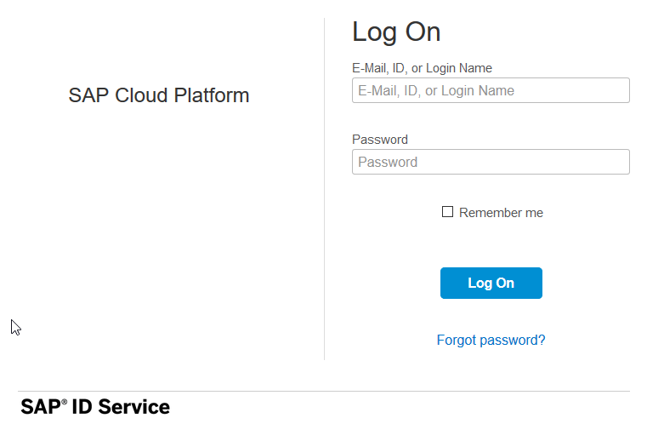  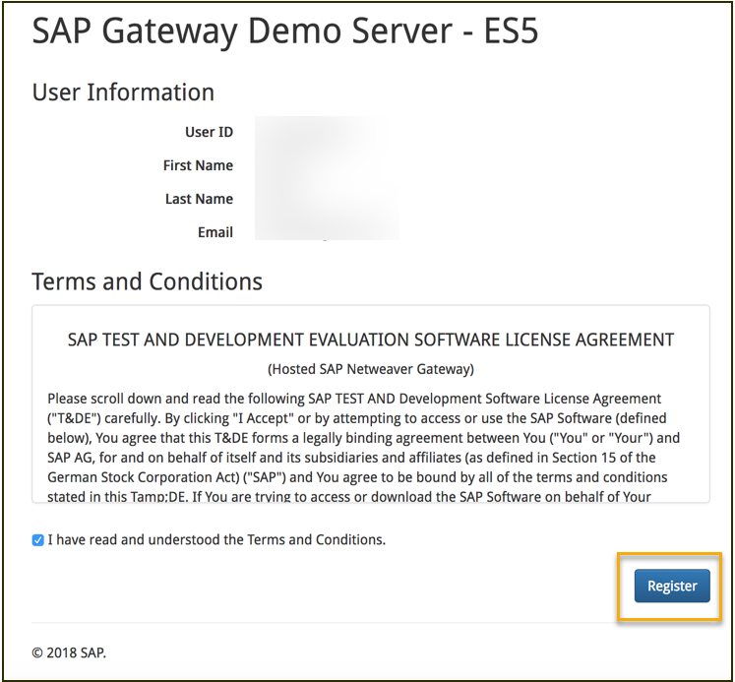
- If an upgrade for your trial account is necessary, you will see an additional step for this during your registration process. Read and acknowledge SAP’s privacy statement, and choose Register. | 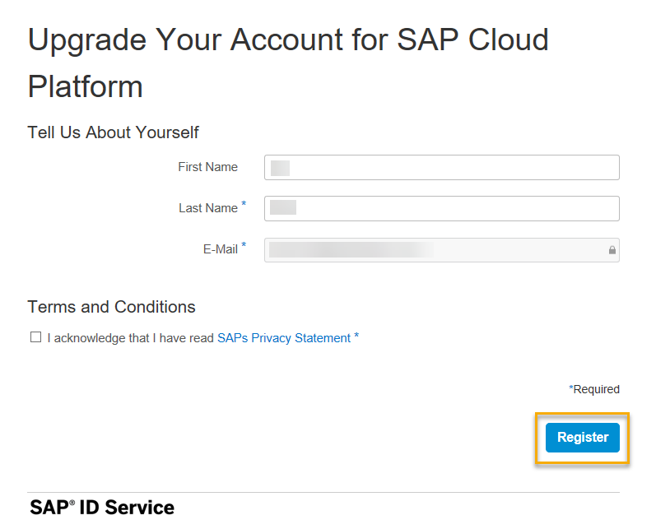
- You will see a success messagefor your registration.  - Go to your e-mail inbox to find the confirmation e-mail, or follow the instructions on the screen to log on to the SAP Gateway WebGUI (https://sapes5.sapdevcenter.com/). | 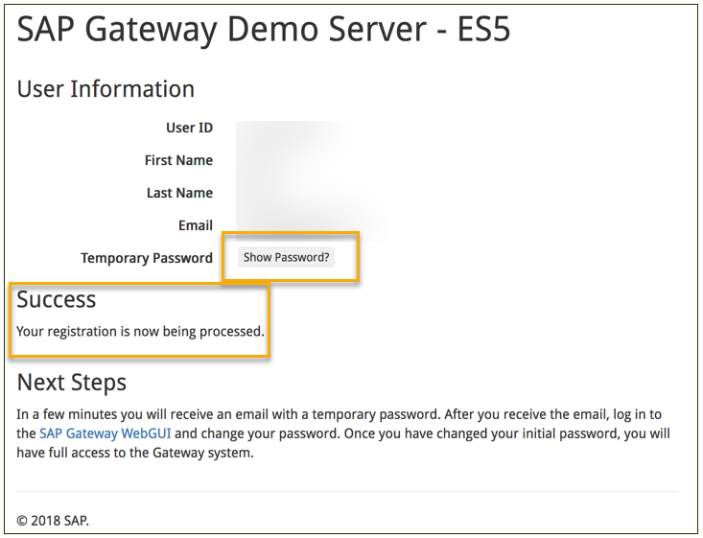
- Log on with your user name and temporary password. | 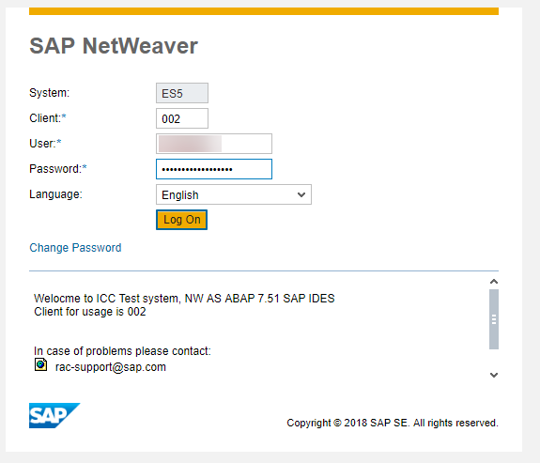
- Change the password from a temporary to a permanent password.  - Write down the new password for the next configuration step. | 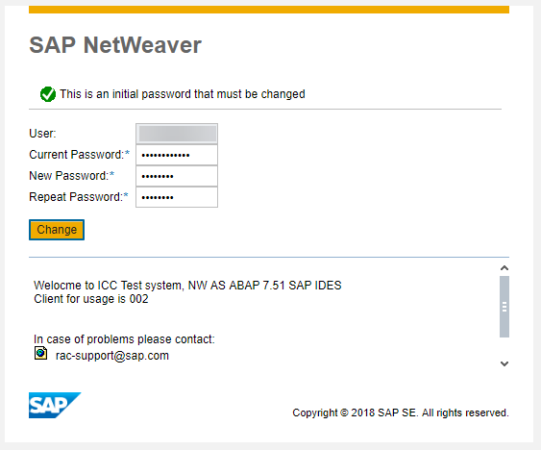
- The initial screen appears, which means your user ID and password work. You’re all set to create a destination in the SAP Cloud Platform Cockpit. This destination will then be the connection between the service and your app. | 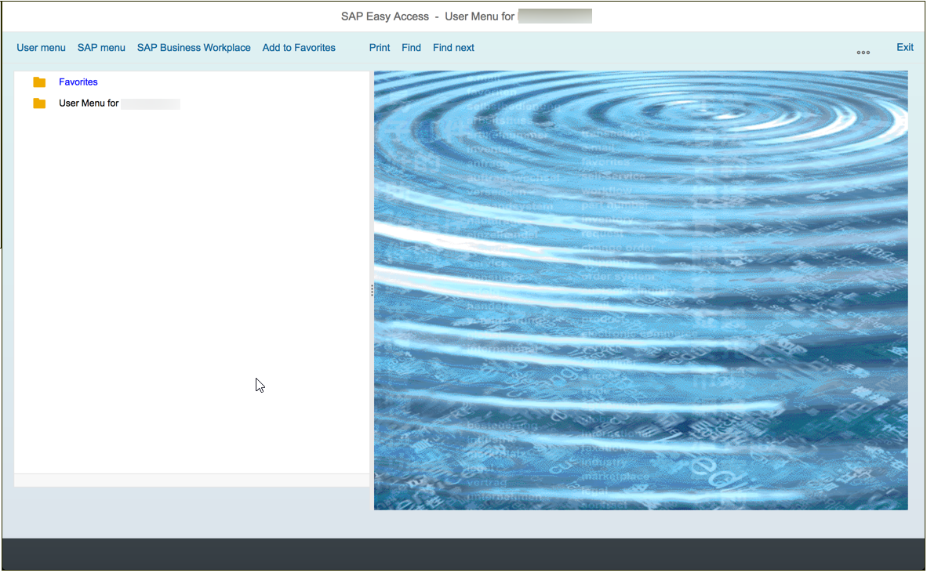
- To get to the SAP Cloud Platform Cockpit, go to your Web IDE Full-Stack trial account (use your bookmark, if have set it).  - Go to Tools SAP Cloud Platform Cockpit. | 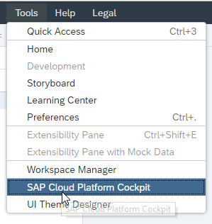
- In the SAP Cloud Platform Cockpit, choose Connectivity Destinations.  - Choose Import Destination. Leave the import popup open as you perform the next step. | 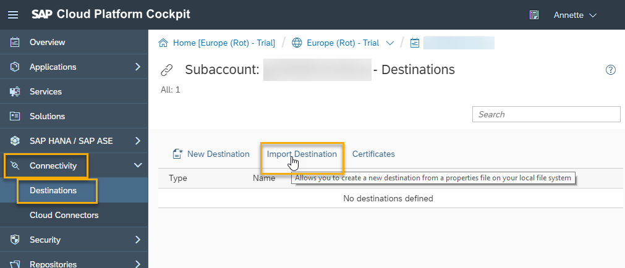
- In another tab, download the ES5 destination.txt file from the UI52 GitHub repository folder import by right clicking the Raw button and choosing Save Link as…  ES5 Destination on GitHub  Save it to your local computer. Then select it in the import popup that appeared after you clicked on Import Destination. | 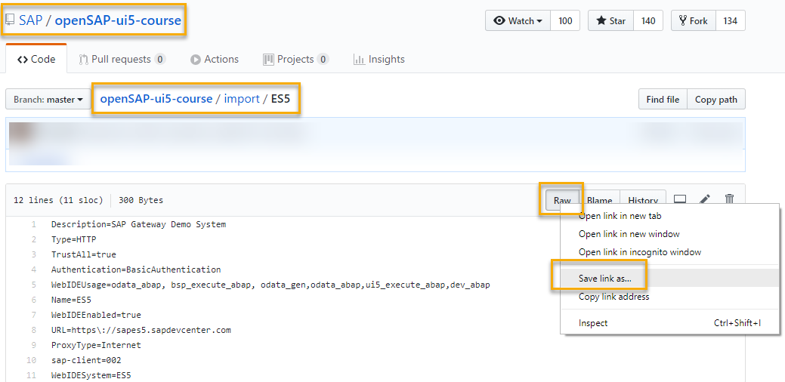
- Ensure the field entries match the screenshot on the right side, and enter your user name and password for the SAP Gateway Demo System.  - Choose Save.  Note: Additional Properties  WebIDEEnabled: This makes this destination visible to SAP Web IDE.  WebIDESystem: This is the system ID that the service runs on.  WebIDEUsage: You can enter multiple usages for a destination, separated by commas without spaces. | 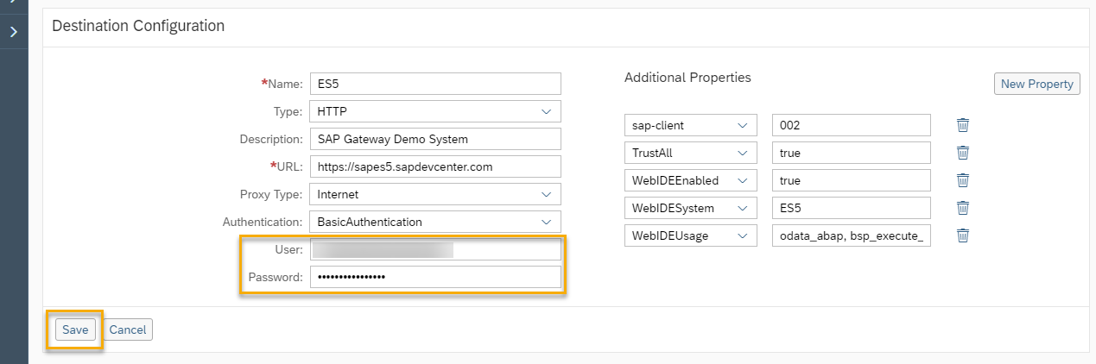
- This is the resulting destination configuration. Next, click on Check Connection to test if the URL is plausible.  Note: Check Connection does not check user credentials  An incorrect user or password does not cause this test to fail, because it only tests the URL connectivity, not the authentication to the system. | 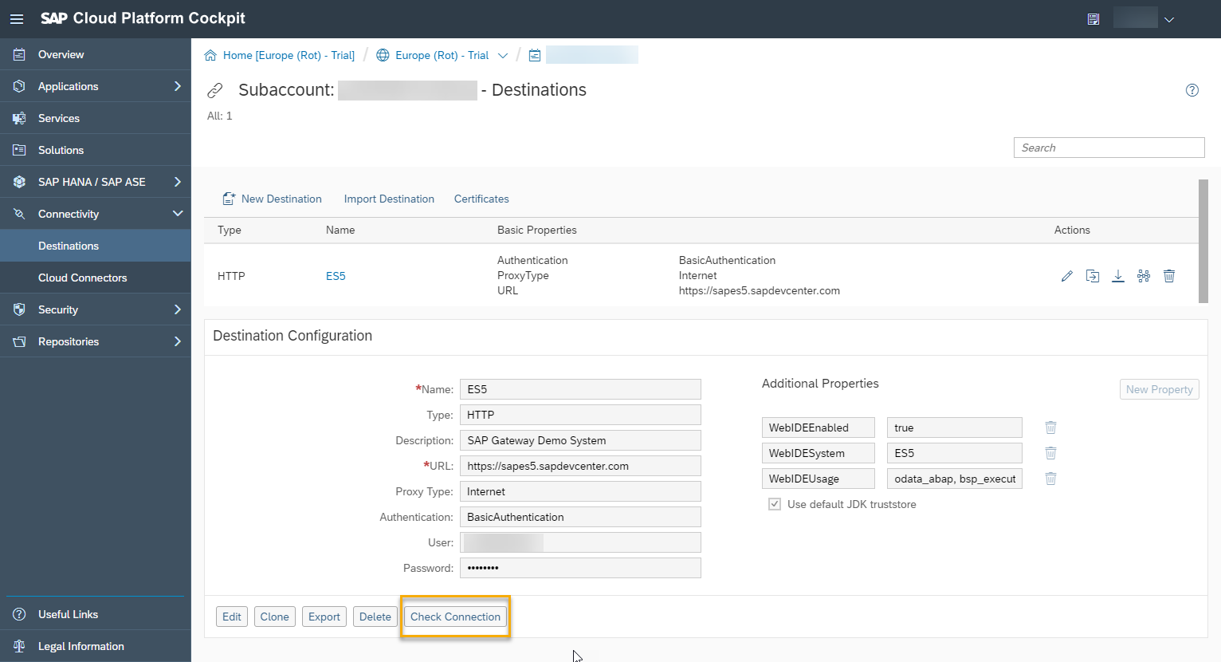
- If you see the message on the right, the test was successful, and the URL is correct. | 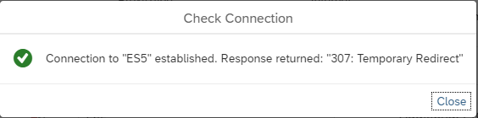

Preview the application

Explanation | Screenshot
- Open the SAP Fiori launchpad in the ES5 system: https://sapes5.sapdevcenter.com/sap/bc/ui5_ui5/ui2/ushell/shells/abap/FioriLaunchpad.html?sap-client=002&sap-language=EN#Shell-home | 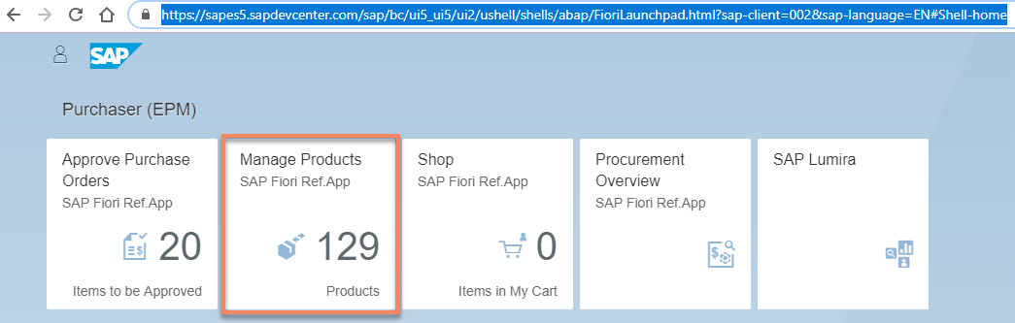
- Open the Manage Products application.

Adding a button to a smart table

Summary

You like this application, but there is a lot of back and forth communication between the UI5 air cargo employees and their customers. They often copy and paste product IDs and prices to email. You would like to improve that by adding a button to the smart table that allows the end user to send search results to another user via email.

Preview
In this exercise, you will learn how to use adaptation projects to extend existing SAPUI5 applications without changing the source application’s code. You will create a variant of an existing SAP Fiori elements application and add a button that sends an email containing the results of a search.

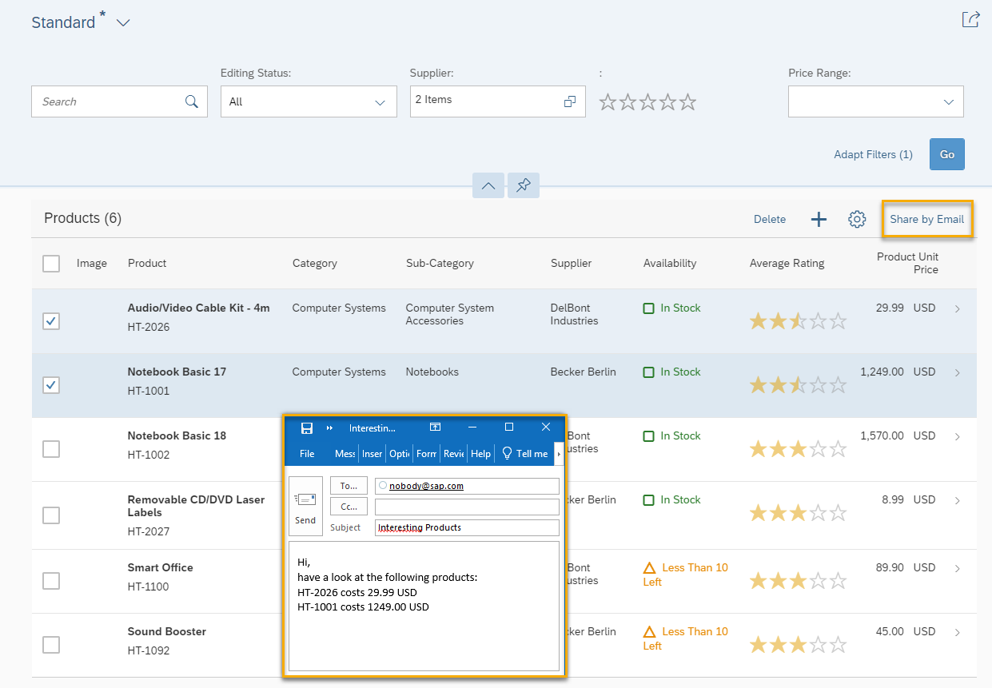
Figure 2 – A Share by Email button added to a variant of an existing application

Create adaptation project

Explanation | Screenshot
- Open SAP Web IDE.
- Create a new adaptation project:  Open the context menu on the Workspace folder, and choose New Adaptation Project. | 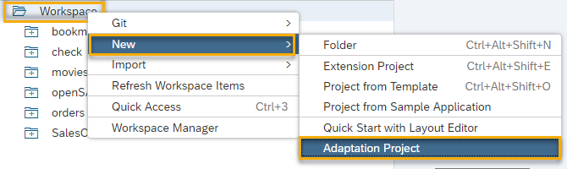
- Enter a project name, and an application title, then choose Next.  Project Name: ui5con.manage.products  Application Title: Manage Cargo  Namespace: <accept default value>  Note: Remember the namespace. It will be important for your accessing your added controls and controller extensions. | 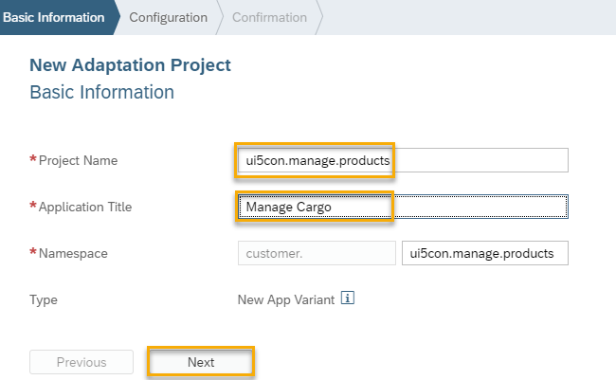
- Select a system and source application upon which to base the variant you are about to create.  Select SAP Gateway Demo System (that’s ES5). You may need to enter your user name and password for that system. | 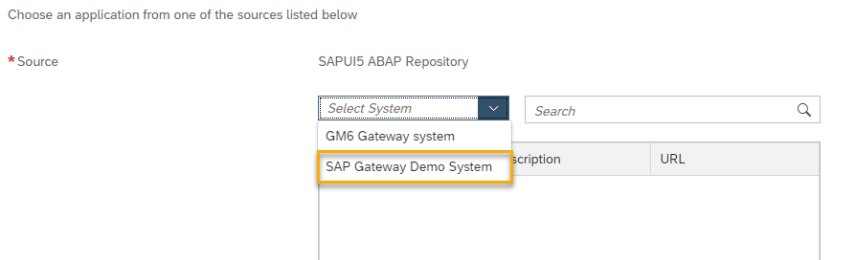
- Select the application with the description Manage Products and choose Finish. | 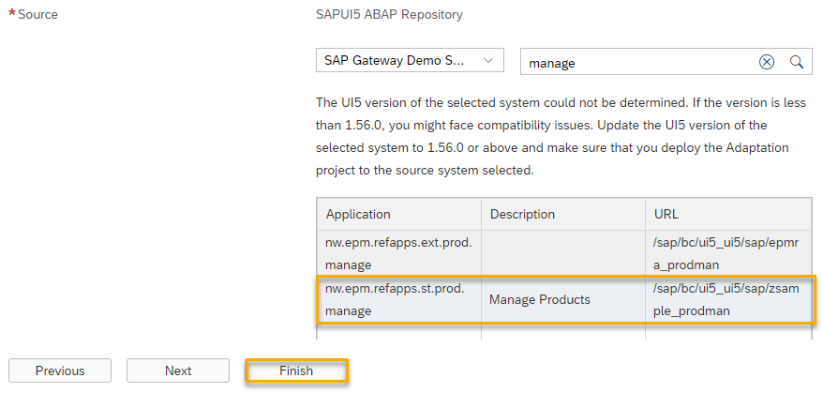
- A new project is created and shows you a working application based on the source application. Any changes you make in this variant are not going to change the code of the source application.  Open this project in the SAPUI5 Visual Editor, where you can preview what the application looks like.  Right-click on the project, and choose SAPUI5 Visual Editor.  Note: You might be prompted for a user name and password. If so, enter your user name and password for the ES5 system. | 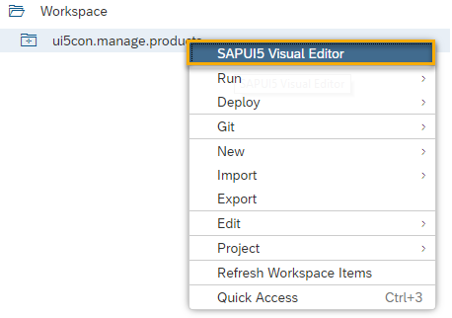
- Inside the running app, do a search where you filter on price range to see how it works.  Choose Go. | 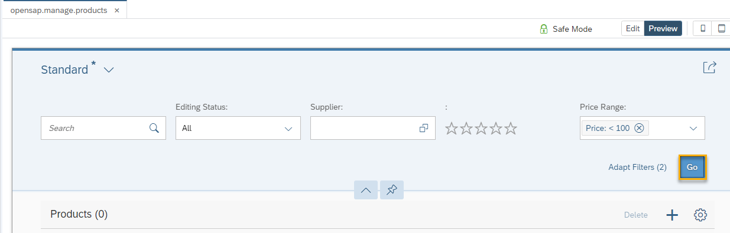

Safe Mode

When you’re in safe mode, you can only make changes that also key users can make in key user adaptation, such as moving sections, renaming fields, etc. However, we want to change more than that. But this also means that we will touch more parts of the source application that might change when the source app is upgraded.

Explanation | Screenshot
- Choose Safe Mode. | 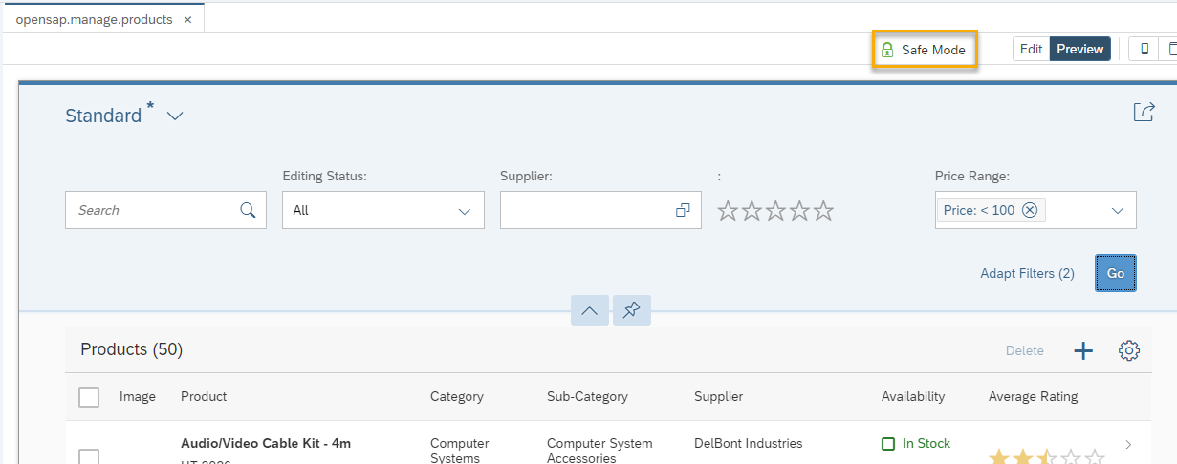
- De-select the Enable Safe Mode checkbox, and choose Apply | 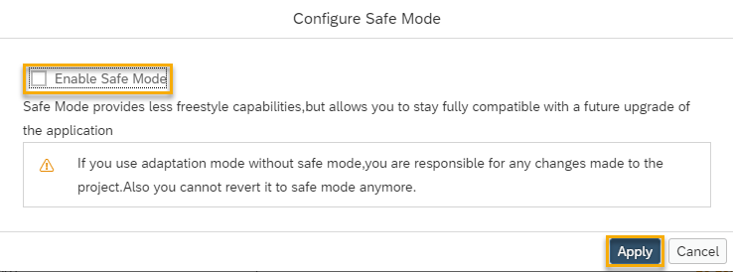
- Choose Edit. | 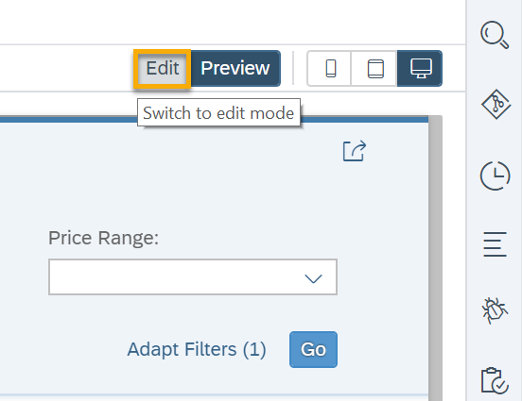

Adding a button as a fragment

With safe mode disabled, you have the generic option to add new SAPUI5 controls anywhere in the application by adding an XML fragment that contains them.

Explanation | Screenshot
- Select the table’s toolbar. | 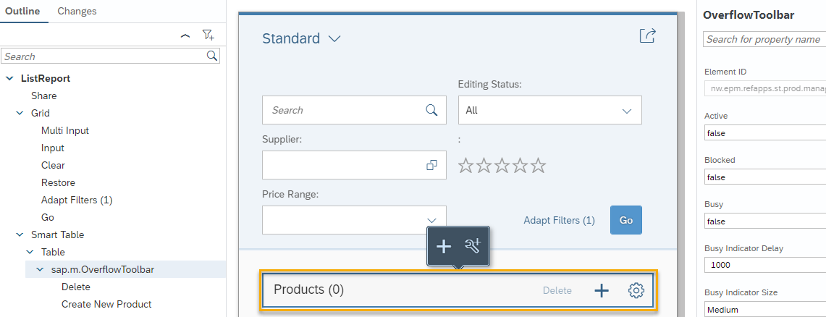
- Right-click on the table toolbar area, and choose the + Add Fragment menu item. | 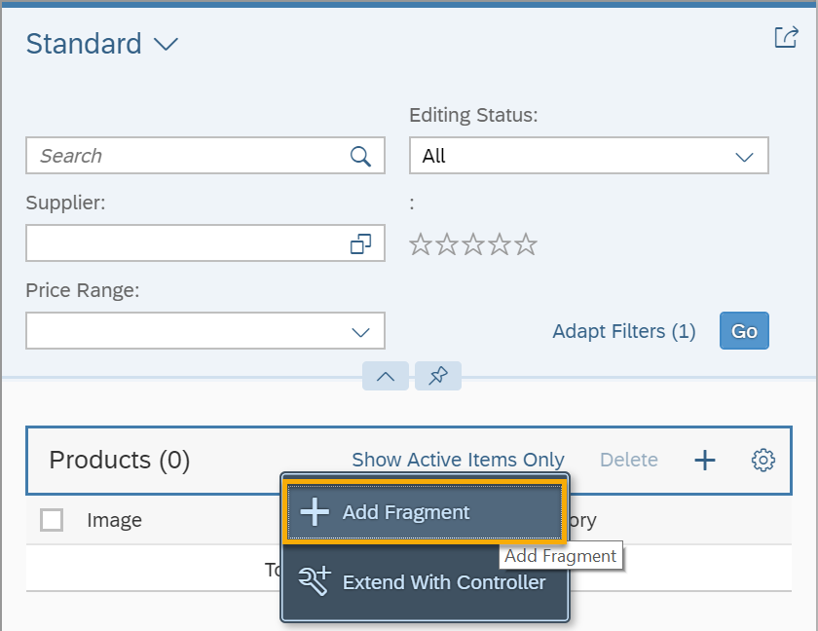
- The Target Aggregation for the new fragment is the preselected content aggregation, and Index should remain the last element in that aggregation.  Choose the Create new link. | 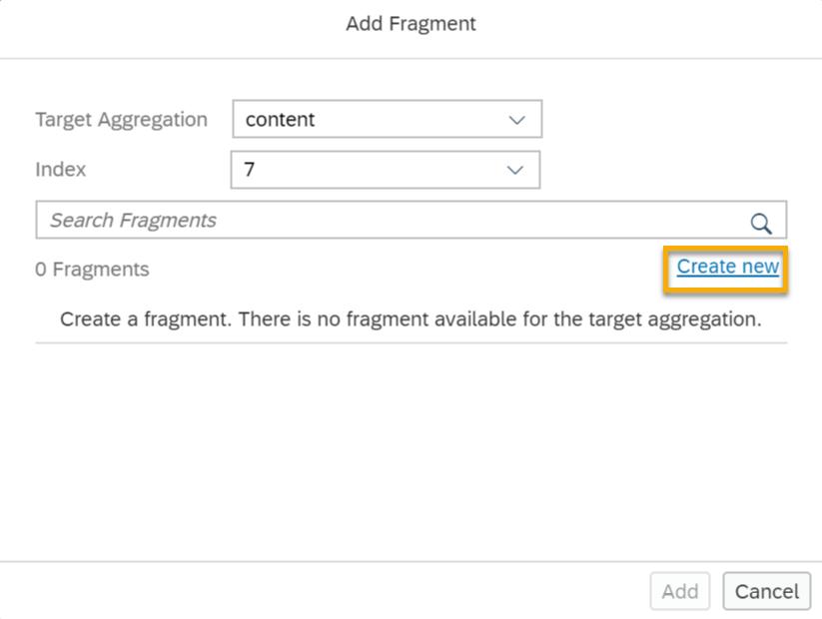
- In the Add Fragment dialog box, enter ShareButton as the fragment name, and choose Create. | 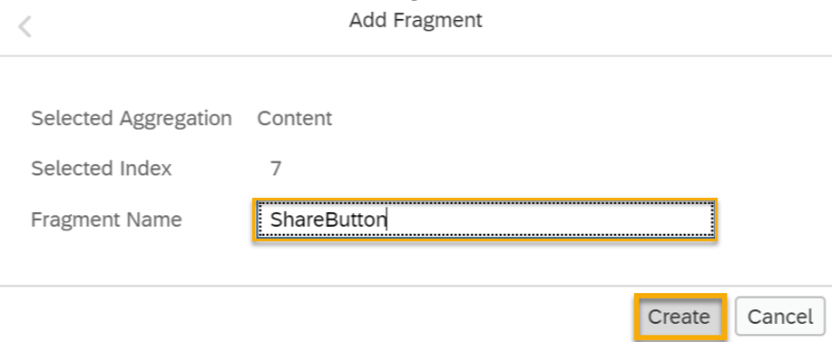
- Now you have a new ShareButton.fragment.xml file that's blank, and you need to add some code. Copy the following code, and paste it to the ShareButton.fragment.xml file. | 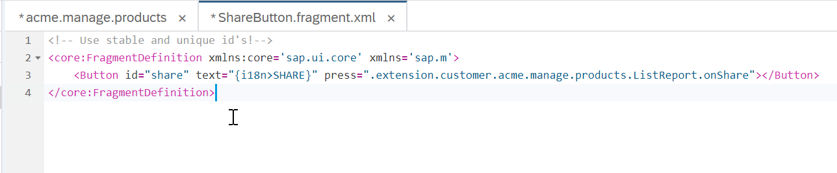

webapp/changes/fragments/ShareButton.fragment.xml

<!-- Use stable and unique id's!-->
<core:FragmentDefinition xmlns:core='sap.ui.core' xmlns='sap.m'>
<Button id="shareByEmail" text="{i18n>SHARE_BY_EMAIL}" press=".extension.customer.ui5con.manage.products.ListReport.onShare"></Button>
</core:FragmentDefinition>

Explanation | Screenshot
- Save. | 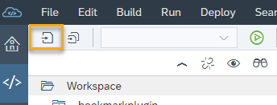
- Go back to the ui5con.manage.products tab, accept the message that says changes were made outside the editor, and let it reload the editor. You may be asked if you want to save unsaved changes in the editor – if so, choose Save. | 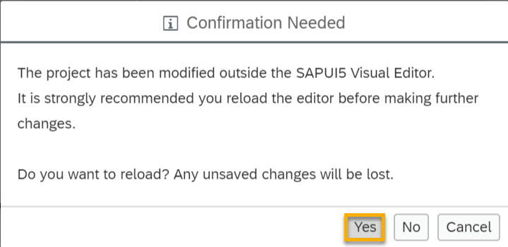

Adding translatable texts

In fragments you might need translatable texts. In the fragment here, there is a reference to a new i18n key SHARE_BY_EMAIL. Now you need to provide some texts for this key. The i18n.properties file can be translated, and language specific files can be provided next to it, like in any UI5 app.

Explanation | Screenshot
- Right-click on the i18n.properties file for the ListReport folder of this project, and choose Open Code Editor. | 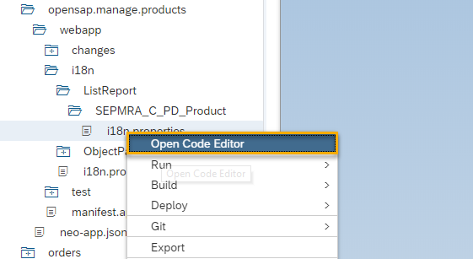
- Add the following text keys to the i18n.properties file and Save. | 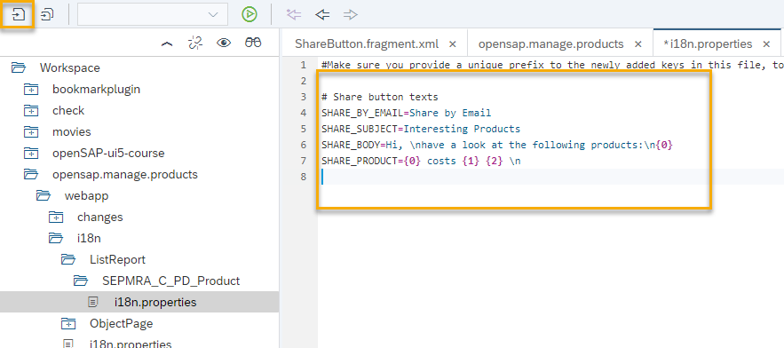

webapp/i18n/ListReport/SEPMRA_C_PD_Product/i18n.properties

#Make sure you provide a unique prefix to the newly added keys in this file, to avoid overriding of SAP Fiori application keys.

# Share button texts
SHARE_BY_EMAIL=Share by Email
SHARE_SUBJECT=Interesting Products
SHARE_BODY=Hi, \nhave a look at the following products:\n{0}
SHARE_PRODUCT={0} costs {1} {2} \n

- Go back to the ui5con.manage.products tab, accept the message that says changes were made outside the editor, and let it reload the editor. You’ll see the new Share by Email button, but there is still no code there to control how it works.  Choose Edit. | 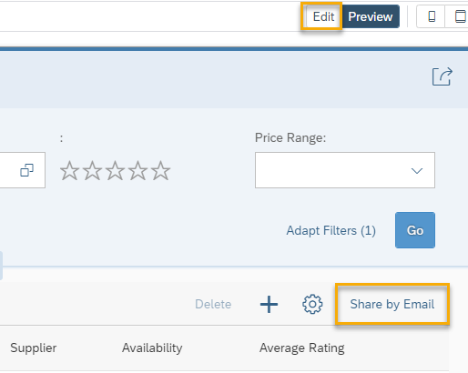
- Optional: If you cannot see the Share by Email button when you’re in edit mode, because the screen area is too small, choose the Collapses left pane button. This will allow you more space to see your application in the editor. | 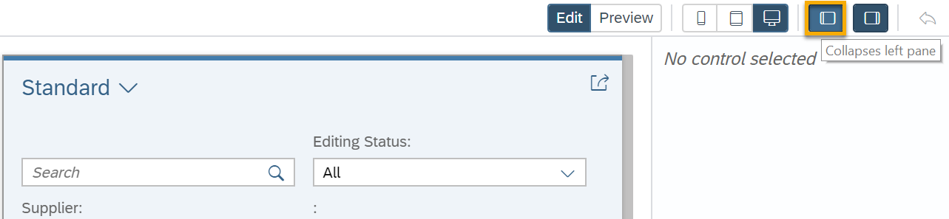

Adding event handler as controller extension

Controller extensions allow you to add functionality like the button’s press event handler.

Explanation | Screenshot
- Right-click the Share by Email button, and choose Extend With Controller. | 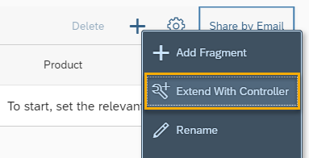
- Enter ListReport as the controller name, and choose Extend. | 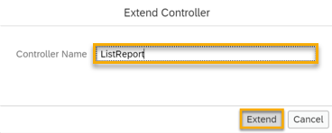
- Now you are looking at a new file, ListReport.js. Notice this is not an empty file.  Replace the contents with the following code and Save afterwards. | 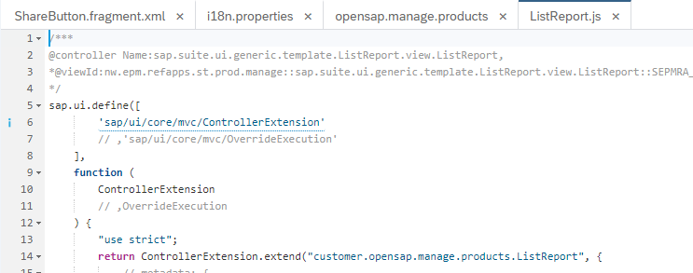

webapp/changes/coding/ListReport.js

/***
@controller Name:sap.suite.ui.generic.template.ListReport.view.ListReport,
*@viewId:nw.epm.refapps.st.prod.manage::sap.suite.ui.generic.template.ListReport.view.ListReport::SEPMRA_C_PD_Product
*/
sap.ui.define([
"sap/ui/core/mvc/ControllerExtension"
// ,"sap/ui/core/mvc/OverrideExecution"
],
function (
ControllerExtension
// ,OverrideExecution
) {
"use strict";

return ControllerExtension.extend("customer.ui5con.manage.products.ListReport", {

onShare: function (oEvent) {
//Similar use case: https://ui5.sap.com/#/topic/a269671fc49e4c75920c108961bf31f2

// 1. Get SAP Fiori elements extensionAPI instance:
// * SAP Fiori elements ListReport base controller is accessed by this.base
// * templateBaseExtension provides public API for SAP Fiori elements extensions, like the extensionAPI that is also used by SAP Fiori elements developers
var oExtensionAPI = this.base.templateBaseExtension.getExtensionAPI();

// 2. Get selected products via extensionAPI methods
// see https:// ui5.sap.com/#/api/sap.suite.ui.generic.template.ListReport.extensionAPI.ExtensionAPI/methods/getSelectedContexts
var aSelection = oExtensionAPI.getSelectedContexts();
if (aSelection.length > 0) {
// access your i18n model where the texts are available
var oResourceBundle = this.getView().getModel("i18n").getResourceBundle();

var sTo = "nobody@sap.com";
var sSubject = oResourceBundle.getText("SHARE_SUBJECT");
var sProducts = aSelection.reduce(function (sText, oSelectedContext) {
// for each selected product, get the OData entity
var mSelectedData = oSelectedContext.getObject();
// add a line with some entity informaton to your email
return sText + oResourceBundle.getText("SHARE_PRODUCT", [mSelectedData.Product, mSelectedData.Price, mSelectedData.Currency]);
}, "");
// combine the body text
var sBody = oResourceBundle.getText("SHARE_BODY", [sProducts]);
// use SAPUI5 helper functionality to prepare the email
sap.m.URLHelper.triggerEmail(sTo, sSubject, sBody);
}
}
});
});

Preview results

Now let’s see your work in action and preview this as a web application.

Explanation | Screenshot
- Choose Run Run as Web Application. | 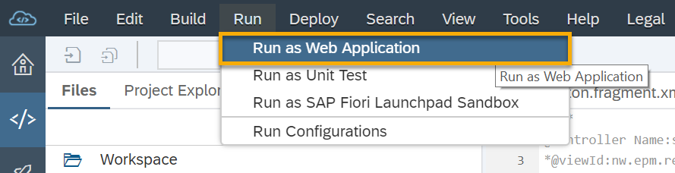
- If asked which configuration to use, select the Adaptation_index.html and choose OK. | 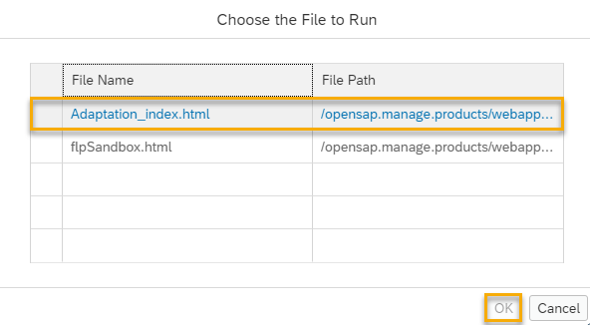
- Now you’re running your application! Filter for a supplier’s name. Then select the items you’d like to share, and choose the Share by Email button. | 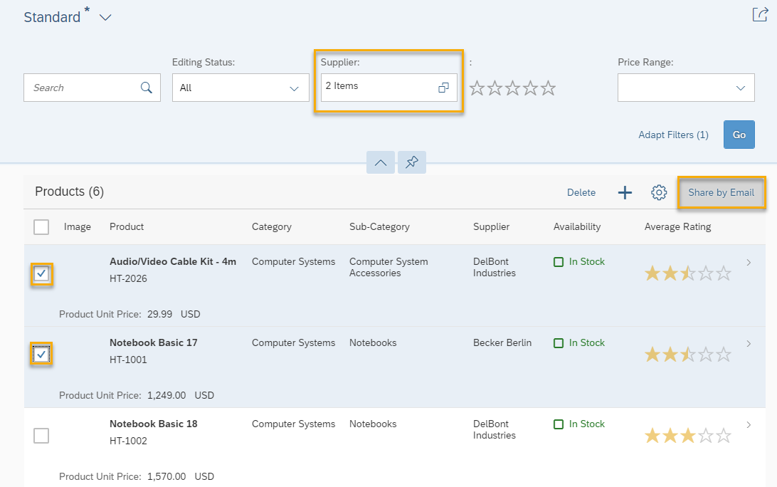
- A new email is created using your computer’s default email program. It contains the data that you selected! | 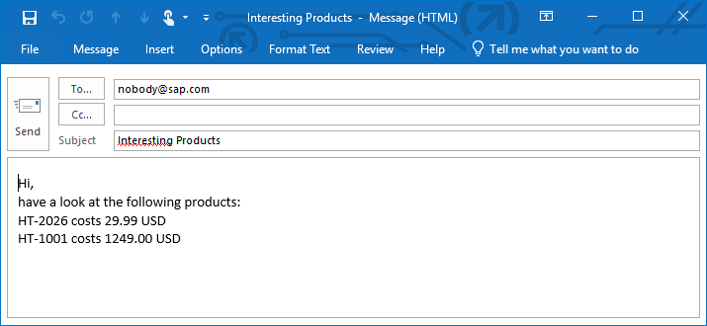

Adding a Dimension Filter

Summary

For an air cargo company, it is essential to use all the space available on an air craft. UI5 Air Cargo uses standardized boxes for all products. Once in a while, there is space left and UI5 Air Cargo employees would like to know which products could fit in.

You should add a special filter to the filter bar for products that fit into one of the following box types that UI5 Air Cargo uses:
• Small boxes of 10 cm in each dimension
• Medium boxes of 20 cm in each dimension
• Large boxes above 20 cm in each dimension

In this exercise, you will continue to adapt the application variant you created in the exercises.

Preview
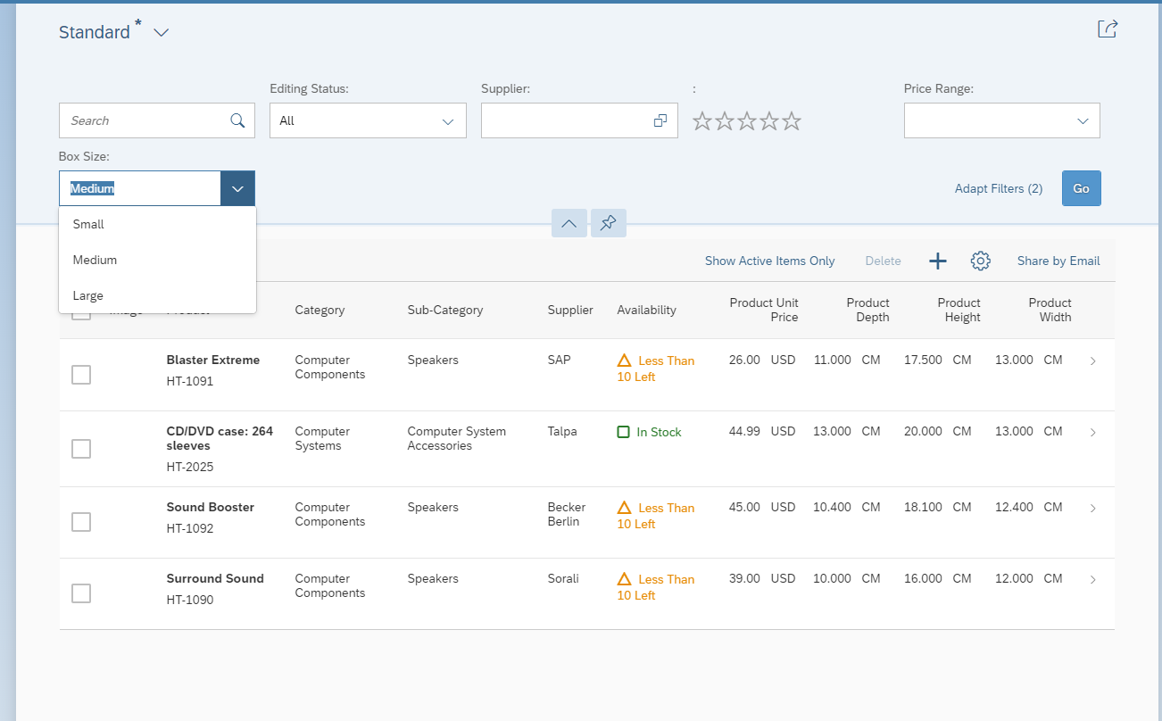
Figure 3 – An additional filter for box sizes added to the app variant

Hints:
- Adaptation Extension Example: Adding a Button to the Table Toolbar in the List Report
- You can make additional columns visible via table personalization.

Adding a filter as a fragment

With safe mode disabled, you have the generic option to add new SAPUI5 controls anywhere in the application by adding an XML fragment that contains them. We will also use this to add the filter.

Explanation | Screenshot
- Open SAP Web IDE.
- First you need to open the application variant you created in the first exercise.
Right-click on ui5con.manage.products, and choose SAPUI5 Visual Editor.
Note: You might be prompted for a user name and password. If so, enter your user name and password for the ES5 system.
- Next, let’s do a search of what products are available. Choose Go. | 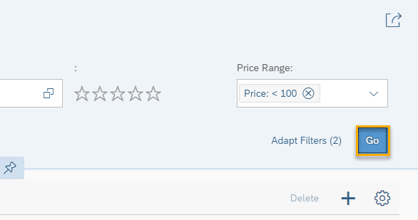
- Personalize the table | 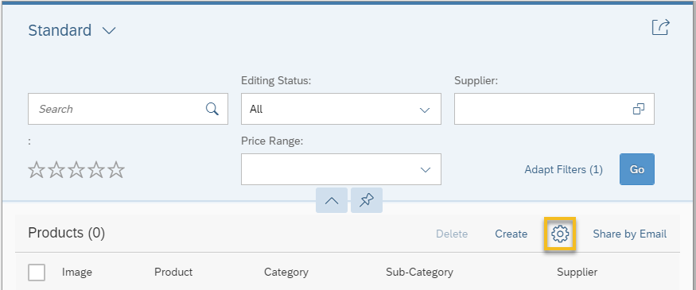
- Select Product Depth, Height and Width columns | 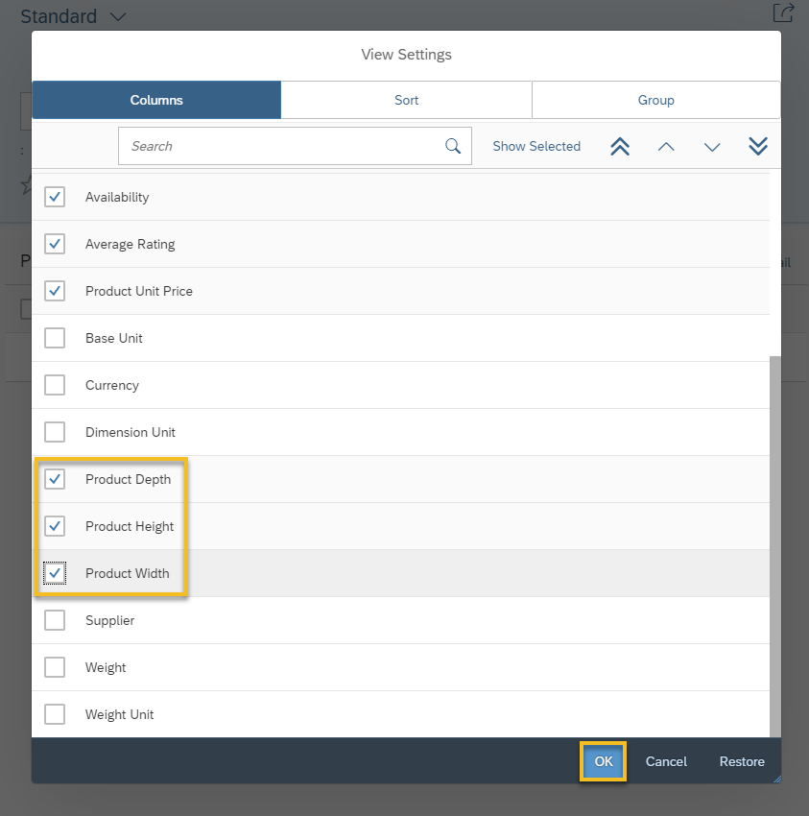
- Choose Edit.
- Select the filterbar area and open the context menu | 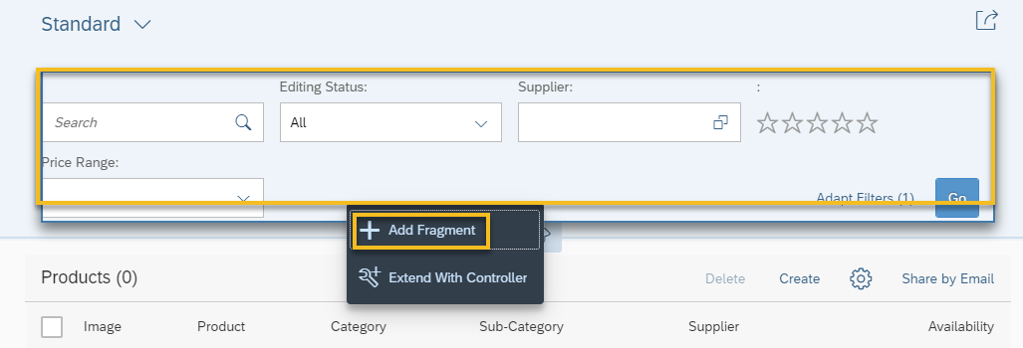
- The Target Aggregation for the new fragment needs to be changes to controlConfiguration, and Index should remain the last element in that aggregation.  Choose the Create new link  Note: You can check the control’s API documentation about the functionality of the different aggregations, in this case: https://ui5.sap.com/#/api/sap.ui.comp.smartfilterbar.SmartFilterBar | 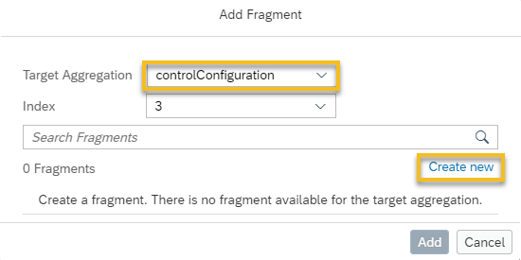
- In the Add Fragment dialog box, enter BoxFilter as the fragment name, and choose Create | 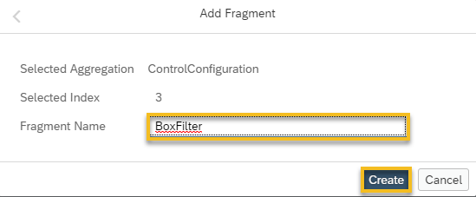
- Now you have a new BoxFilter.fragment.xml file that's blank, and you need to add some code. Copy the following code, and paste it to the BoxFilter.fragment.xml file. | 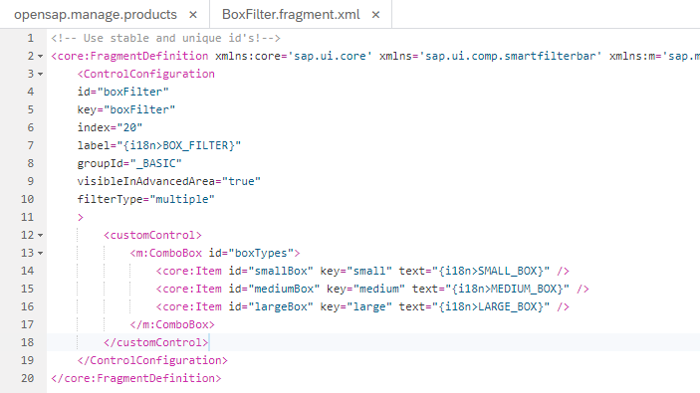

webapp/changes/fragments/BoxFilter.fragment.xml

<!-- Use stable and unique id's!-->
<core:FragmentDefinition xmlns:core='sap.ui.core' xmlns='sap.ui.comp.smartfilterbar' xmlns:m='sap.m'>
<ControlConfiguration
id="boxFilter"
key="boxFilter"
index="20"
label="{i18n>BOX_FILTER}"
groupId="_BASIC"
visibleInAdvancedArea="true"
filterType="multiple"
>
<customControl>
<m:ComboBox id="boxTypes">
<core:Item id="smallBox" key="small" text="{i18n>SMALL_BOX}" />
<core:Item id="mediumBox" key="medium" text="{i18n>MEDIUM_BOX}" />
<core:Item id="largeBox" key="large" text="{i18n>LARGE_BOX}" />
</m:ComboBox>
</customControl>
</ControlConfiguration>
</core:FragmentDefinition>

Adding translatable texts

Explanation | Screenshot
- Right-click on the i18n.properties file for the ListReport folder of this project, and choose Open Code Editor.
- Add the following text keys to the i18n.properties file and Save.

webapp/i18n/ListReport/SEPMRA_C_PD_Product/i18n.properties

...
SHARE_BODY=Hi, \nhave a look at the following products:\n{0}
SHARE_PRODUCT={0} costs {1} {2} \n

# Box Filter texts
BOX_FILTER=Box Size
SMALL_BOX=Small
MEDIUM_BOX=Medium
LARGE_BOX=Large

- Go back to the ui5con.manage.products tab, accept the message that says changes were made outside the editor, and let it reload the editor. You’ll see the new texts for the filter, but there is still no code there to filter how it works. | 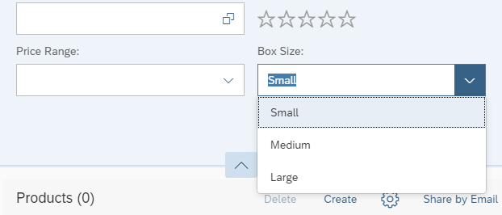

Adding event handler as controller extension

Controller extensions allow you to hook into functionality of the base controller.

webapp/changes/coding/ListReport.js

/***
@controller Name:sap.suite.ui.generic.template.ListReport.view.ListReport,
*@viewId:nw.epm.refapps.st.prod.manage::sap.suite.ui.generic.template.ListReport.view.ListReport::SEPMRA_C_PD_Product
*/
sap.ui.define([
"sap/ui/core/mvc/ControllerExtension",
"sap/ui/model/Filter",
"sap/ui/model/FilterOperator"
// ,"sap/ui/core/mvc/OverrideExecution"
],
function (
ControllerExtension,
Filter,
FilterOperator
// ,OverrideExecution
) {
"use strict";

//box type definition:
var BOX_TYPES = {
small: new Filter({
filters: [
new Filter({
path: "Height",
operator: FilterOperator.BT,
value1: 0,
value2: 10
}),
new Filter({
path: "Width",
operator: FilterOperator.BT,
value1: 0,
value2: 10
}),
new Filter({
path: "Depth",
operator: FilterOperator.BT,
value1: 0,
value2: 10
})
],
and: true
}),
medium: new Filter({
filters: [
new Filter({
path: "Height",
operator: FilterOperator.BT,
value1: 10,
value2: 20
}),
new Filter({
path: "Width",
operator: FilterOperator.BT,
value1: 10,
value2: 20
}),
new Filter({
path: "Depth",
operator: FilterOperator.BT,
value1: 10,
value2: 20
})
],
and: true
}),
large: new Filter({
filters: [
new Filter({
path: "Height",
operator: FilterOperator.GT,
value1: 20
}),
new Filter({
path: "Width",
operator: FilterOperator.GT,
value1: 20
}),
new Filter({
path: "Depth",
operator: FilterOperator.GT,
value1: 20
})
],
and: true
})
};
return ControllerExtension.extend("customer.ui5con.manage.products.ListReport", {
// this section allows to extend lifecycle hooks or override public methods of the base controller
override: {
// override public methods of the ListReport controller and its members like templateBaseExtension
templateBaseExtension: {
/**
* Can be used to add filters. They will be combined via AND with all other filters
* sControlId is the ID of the control on which extension logic to be applied.
* For each filter the extension must call fnAddFilter(oControllerExtension, oFilter)
* oControllerExtension must be the ControllerExtension instance which adds the filter
* oFilter must be an instance of sap.ui.model.Filter
*/
addFilters: function (fnAddFilter, sControlId) {
var oComboBox = this.byId("boxTypes");
var sSelectedBoxType = oComboBox.getSelectedKey();
//lookup the filters from the definition
var oFilter = BOX_TYPES[sSelectedBoxType];
if (oFilter) {
fnAddFilter(this, oFilter);
}
}
}
},
onShare: function (oEvent) {
...

Preview results

Now let’s see your work in action and preview this as a web application.

Explanation | Screenshot
- Choose Run Run as Web Application.
- If asked which configuration to use, select the Adaptation_index.html and choose OK.
- Now you’re running your application!  Add the product dimension columns via personalization and filter the product list with new the Box Size filter. | 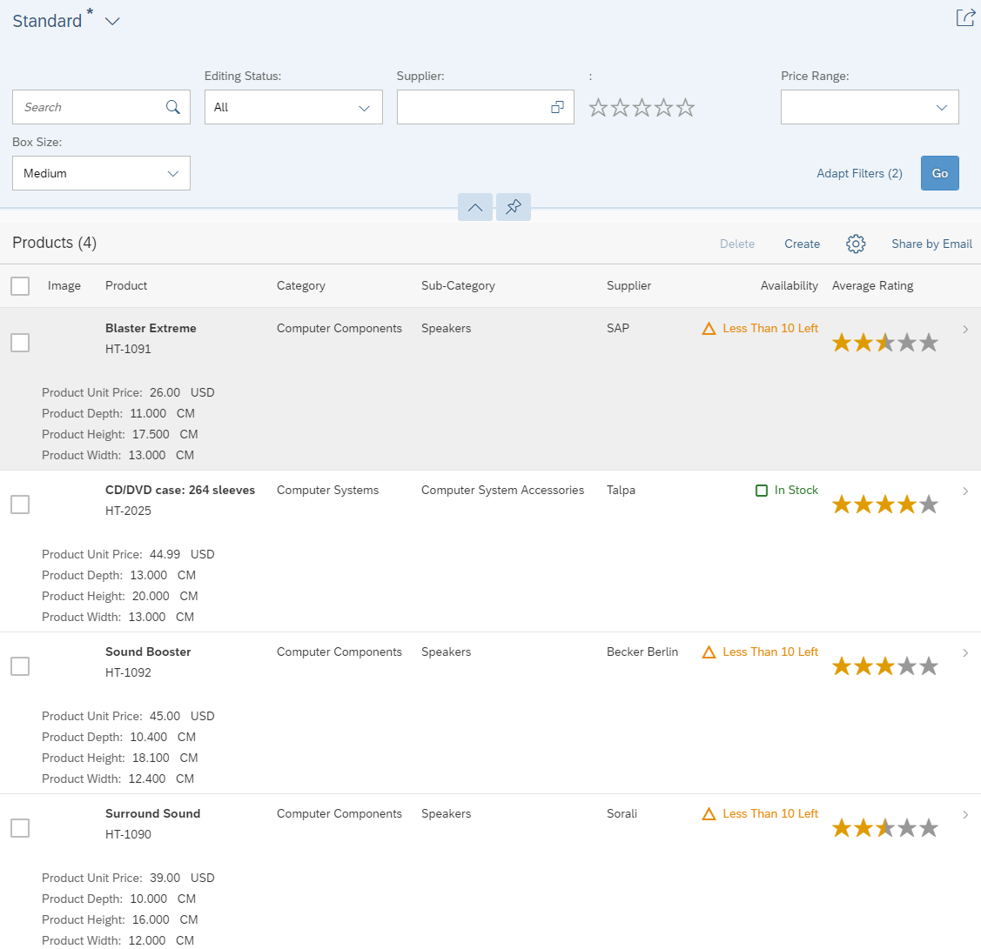

Adding a map to show the supplier location

Summary

As a very special carrier, UI5 Air cargo, directly flies to its suppliers to pick up the products. To find out where to land close to the supplier’s location, they need the supplier’s address and a map showing the surrounding area. You will continue adapting the application variant you created in the first exercise by adding a map to the application’s object page.

Preview

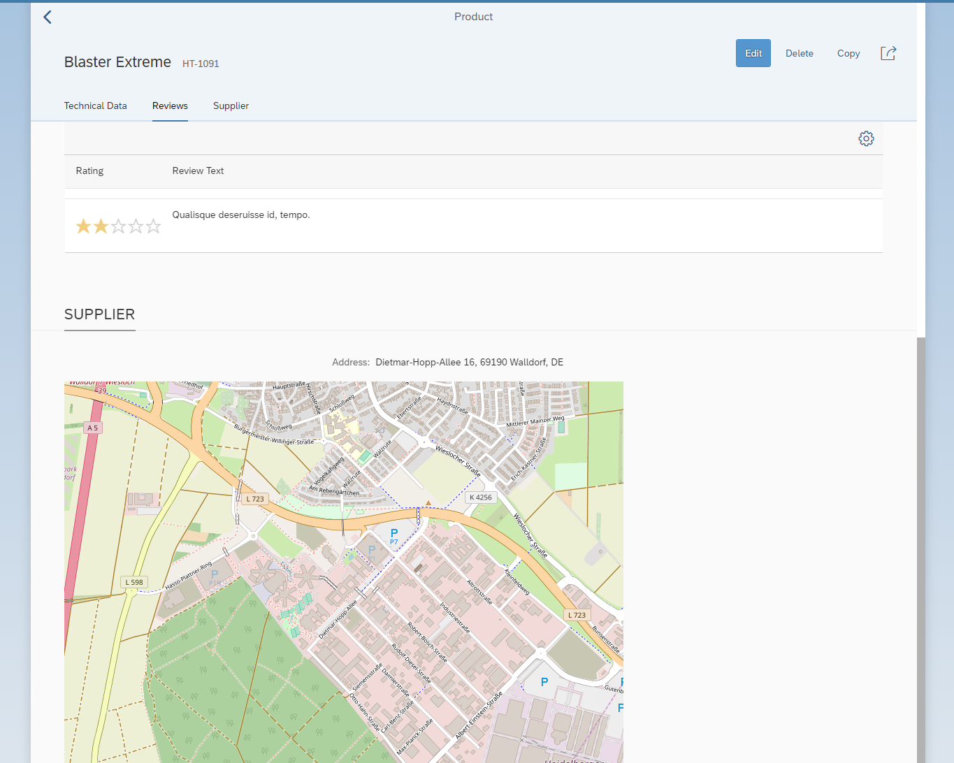
Figure 2 – A map of the product supplier’s location added to the app variant

Hints:
- https://ui5.sap.com/test-resources/sap/ui/vbm/bestpractices.html
- https://open.sap.com/courses/3dmv1

Adding the map

Explanation | Screenshot
- Open SAP Web IDE.
- First you need to open the application variant you created in the first exercise.
Right-click on ui5con.manage.products, and choose SAPUI5 Visual Editor.
Note: You might be prompted for a user name and password. If so, enter your user name and password for the ES5 system.
- Next, let’s do a search of what products are available. Choose Go.
- A list of available products will appear. Select the first item in the list. | 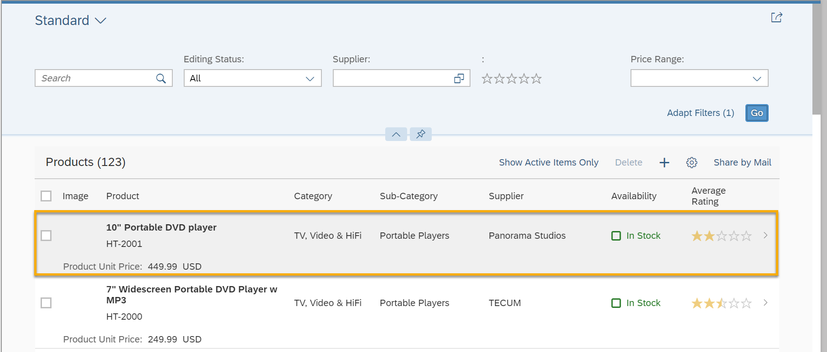
- This will open the object page view of the application, displaying details of the product you selected.  What you are going to do in this exercise is adding a Supplier section and a map to this page, with the map showing the location of the supplier for the product. | 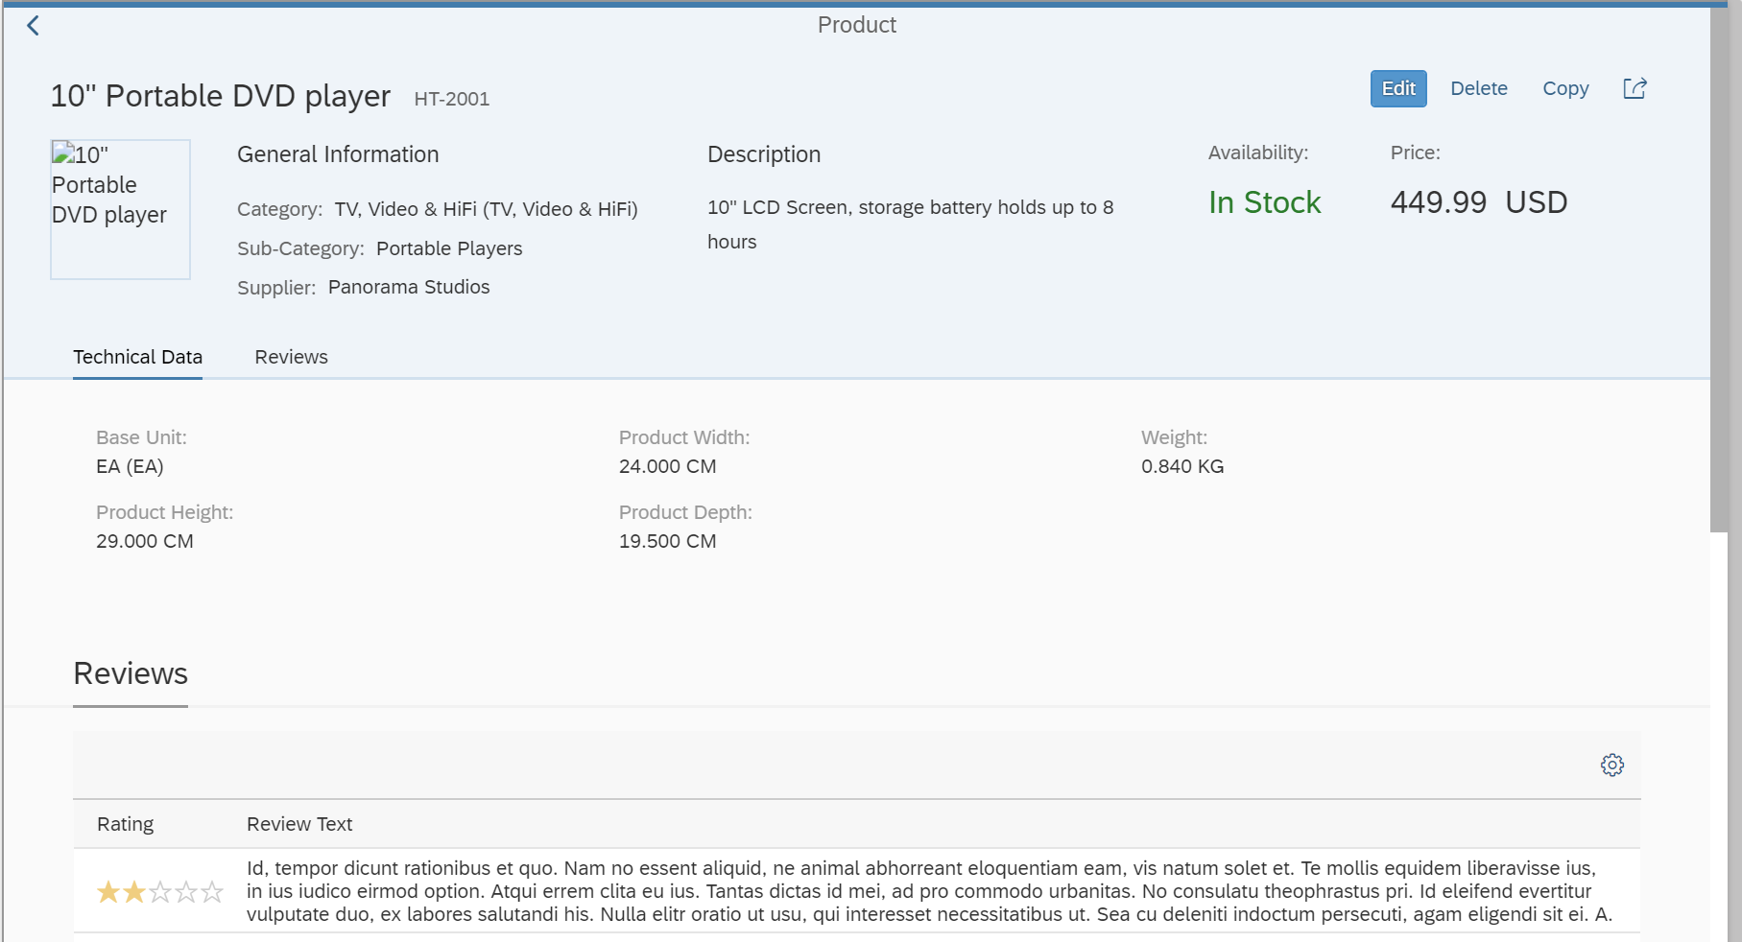
- Choose Edit. | 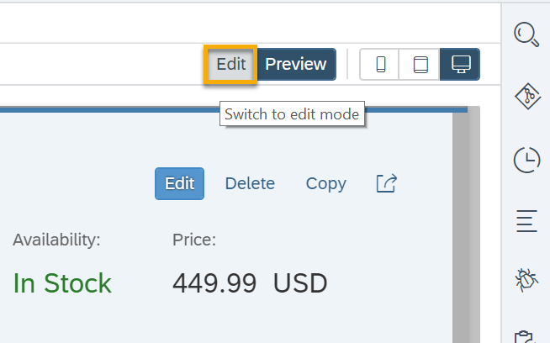
- To add a new section, you need to add a new fragment.  Right click on the object page layout, and choose + Add Fragment. The properties panel shows whether you selected the correct control. | 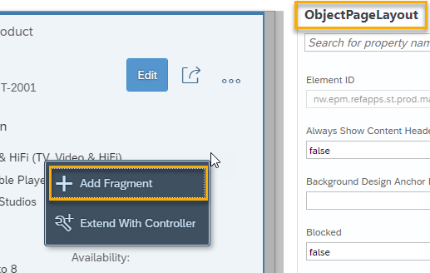
- Here you are going to create a new section for the supplier map.  The target aggregation is the preselected sections aggregation, and the value for Index should remain the last in that aggregation  Choose the Create new link. | 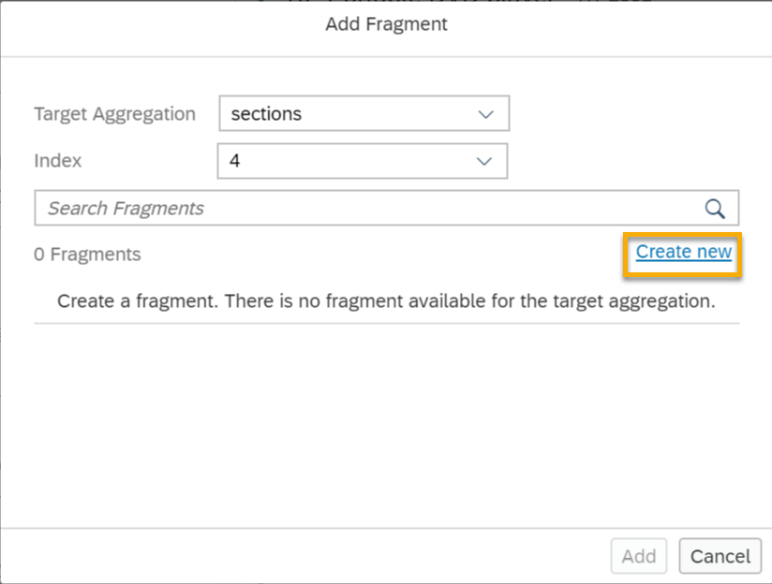
- In the Add Fragment dialog box, enter SupplierMap as the fragment name, and choose Create. | 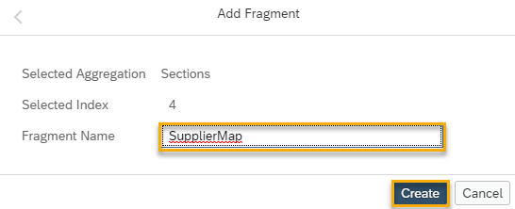
- Now you have a new SupplierMap.fragment.xml file that's blank, and you need to add some content. Copy the following code, paste it to the SupplierMap.fragment.xml, and Save it. | 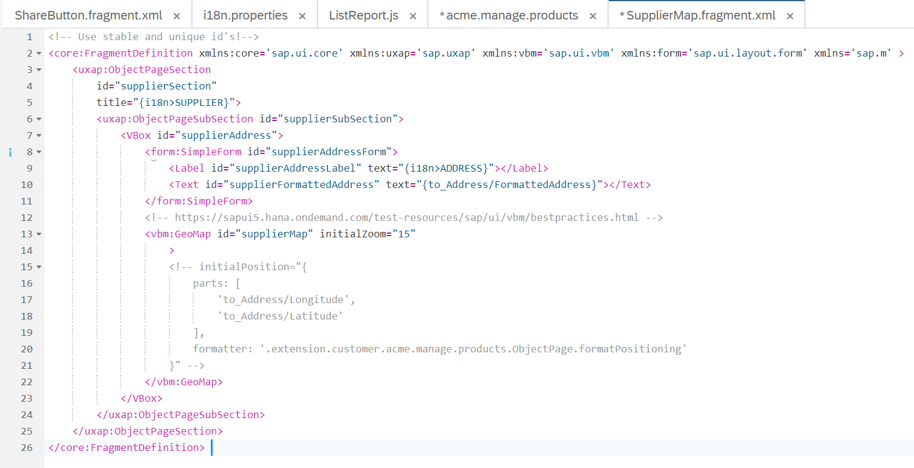

webapp/changes/fragments/SupplierMap.fragment.xml

<!-- Use stable and unique id's!-->
<core:FragmentDefinition xmlns:core='sap.ui.core' xmlns:uxap='sap.uxap' xmlns:vbm='sap.ui.vbm' xmlns:form='sap.ui.layout.form' xmlns='sap.m' >
<uxap:ObjectPageSection
id="supplierSection"
title="{i18n>SUPPLIER}">
<uxap:ObjectPageSubSection id="supplierSubSection">
<VBox id="supplierAddress">
<form:SimpleForm id="supplierAddressForm">
<Label id="supplierAddressLabel" text="{i18n>ADDRESS}"></Label>
<Text id="supplierFormattedAddress" text="{to_Address/FormattedAddress}"></Text>
</form:SimpleForm>
<!-- https://sapui5.hana.ondemand.com/test-resources/sap/ui/vbm/bestpractices.html -->
<vbm:GeoMap id="supplierMap" initialZoom="15">
</vbm:GeoMap>
</VBox>
</uxap:ObjectPageSubSection>
</uxap:ObjectPageSection>
</core:FragmentDefinition>

Adding the texts

Explanation | Screenshot
- To get translatable texts for the new section, add keys to the i18n.properties file. In the tree view of SAP Web IDE, right-click on the i18n.properties for the ObjectPage of this project, and choose Open Code Editor. | 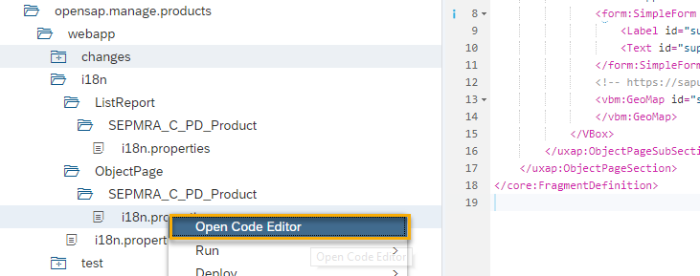
- Copy the following code, and replace the contents of i18n.properties. Then choose Save | 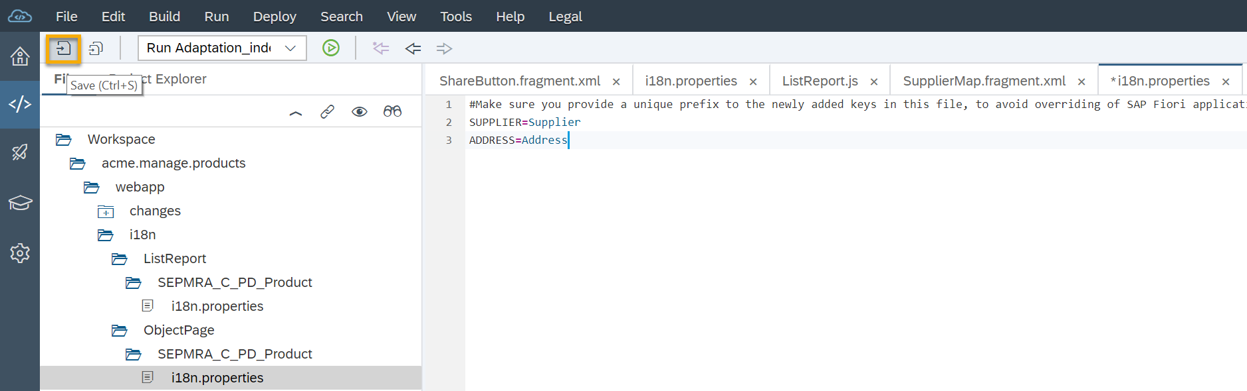

webapp/i18n/ObjectPage/SEPMRA_C_PD_Product/i18n.properties

#Make sure you provide a unique prefix to the newly added keys in this file, to avoid overriding of SAP Fiori application keys.

SUPPLIER=Supplier
ADDRESS=Address

Adding controller extension

Explanation | Screenshot
- Go back to the ui5con.manage.products tab, accept the message that says changes were made outside the editor, and let it reload the editor. You may be asked if you want to save unsaved changes in the editor – if so, choose Save.
- Next, do a search of what products are available. Choose Go. | 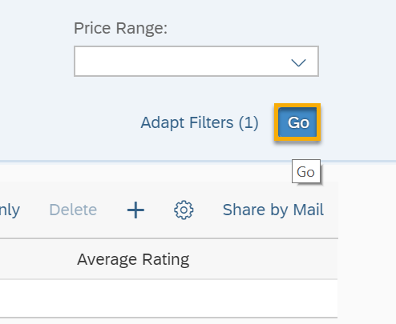
- A list of available products will appear. Choose the first item in the list.
- Now you see a Supplier section on this page.
Choose Edit.
- Right-click on the Supplier section, and choose Extend With Controller. | 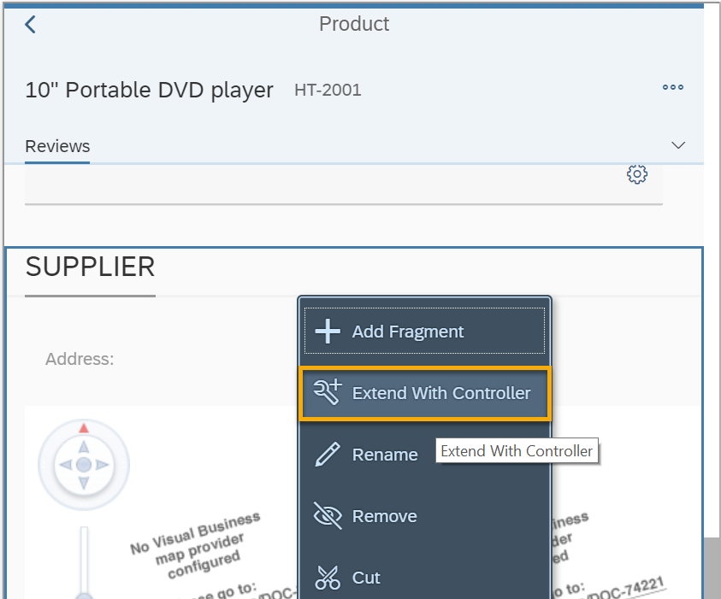
- Enter ObjectPage as the name, and choose Extend. | 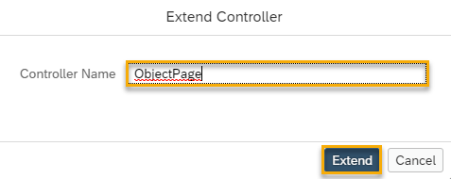
- Now you are looking at a new file, ObjectPage.js.  Replace the contents with the following code and Save afterwards. | 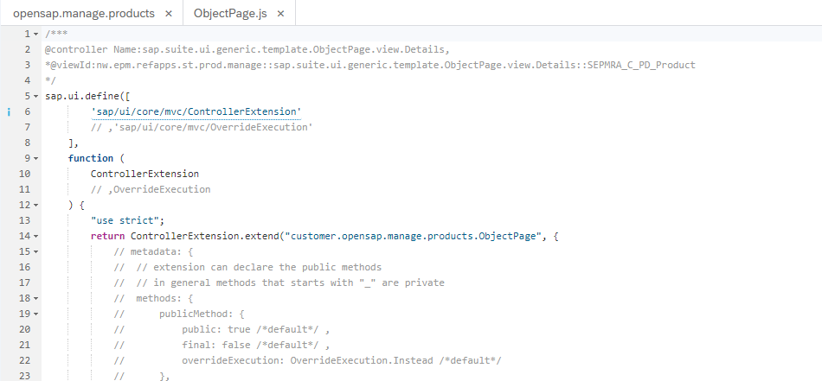

webapp/changes/coding/ObjectPage.js

/***
@controller Name:sap.suite.ui.generic.template.ObjectPage.view.Details,
*@viewId:nw.epm.refapps.st.prod.manage::sap.suite.ui.generic.template.ObjectPage.view.Details::SEPMRA_C_PD_Product
*/
sap.ui.define([
'sap/ui/core/mvc/ControllerExtension'
// ,'sap/ui/core/mvc/OverrideExecution'
],
function (
ControllerExtension
// ,OverrideExecution
) {
"use strict";
return ControllerExtension.extend("customer.ui5con.manage.products.ObjectPage", {
// this section allows to extend lifecycle hooks or override public methods of the base controller
override: {
// /**
// * Called when a controller is instantiated and its View controls (if available) are already created.
// * Can be used to modify the View before it is displayed, to bind event handlers and do other one-time initialization.
// * @memberOf customer.acme.manage.products.ObjectPage.js
// */
onInit: function () {
//configure map to use openstreetmap data
var oMapConfig = {
"MapProvider": [{
"name": "OSM",
"type": "",
"description": "",
"tileX": "256",
"tileY": "256",
"maxLOD": "20",
"copyright": "Tiles Courtesy of OpenMapTiles",
"Source": [{
"id": "s1",
"url": "https://a.tile.openstreetmap.org/{LOD}/{X}/{Y}.png"
}]
}],
"MapLayerStacks": [{
"name": "Default",
"MapLayer": [{
"name": "OSM",
"refMapProvider": "OSM"
}]
}]
};
var oSupplierMap = this.byId("supplierMap");
oSupplierMap.setMapConfiguration(oMapConfig);

//bind the whole section to the supplier including the supplier address
var oSupplierSection = this.byId("supplierSection");
oSupplierSection.bindElement("to_Supplier", {
//inline the address data in the supplier
expand: "to_Address"
});

oSupplierMap.bindProperty("initialPosition", {
parts: [
"to_Address/Longitude",
"to_Address/Latitude"
],
formatter : function(sLong,sLat){
return sLong +";" + sLat + ";0" ;
}
});
}
}
});
});

Preview results

Now let’s see your work in action and preview this as a web application.

Explanation | Screenshot
- Choose Run Run as Web Application.
- If asked which configuration to use, select Adaptation_index.html, and choose OK.
- Now you’re running your application!  Choose Go to start a search, and then select the first item in the results list. | 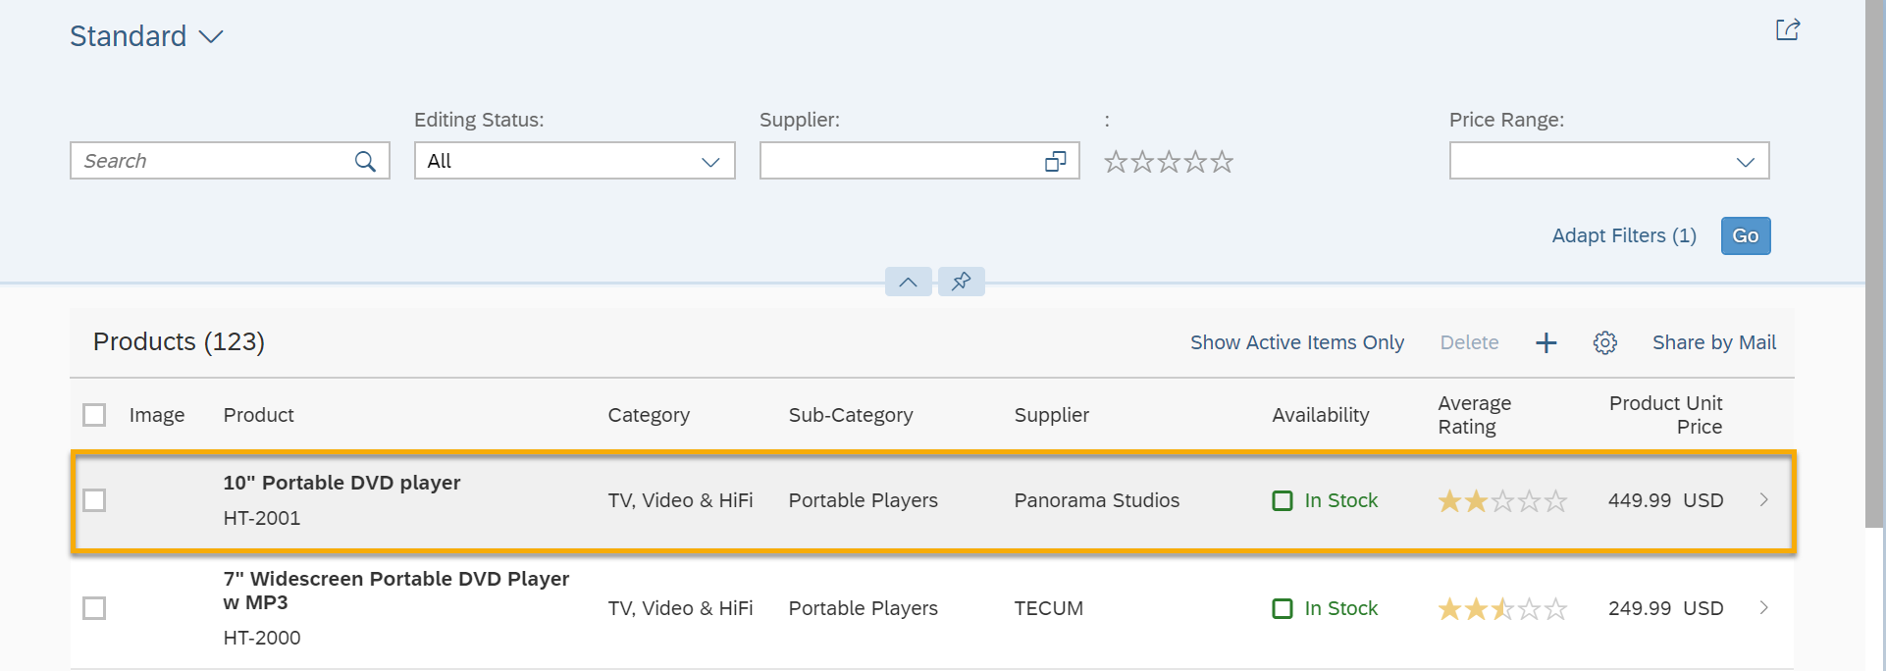
- On the product details page, notice that there is a Supplier tab now.  Click on the Supplier tab (or scroll down to the Supplier section). | 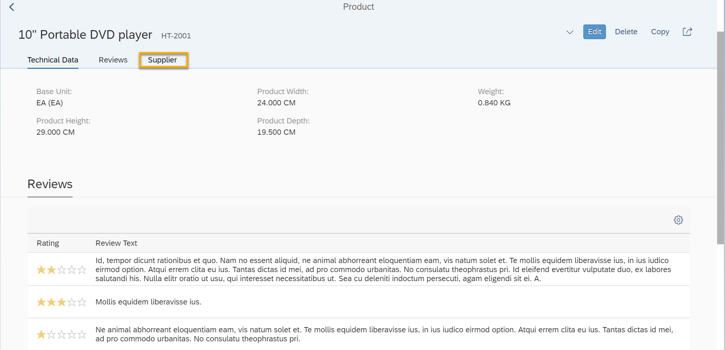
- Voilà, you have a map to show the address and location of the supplier! | 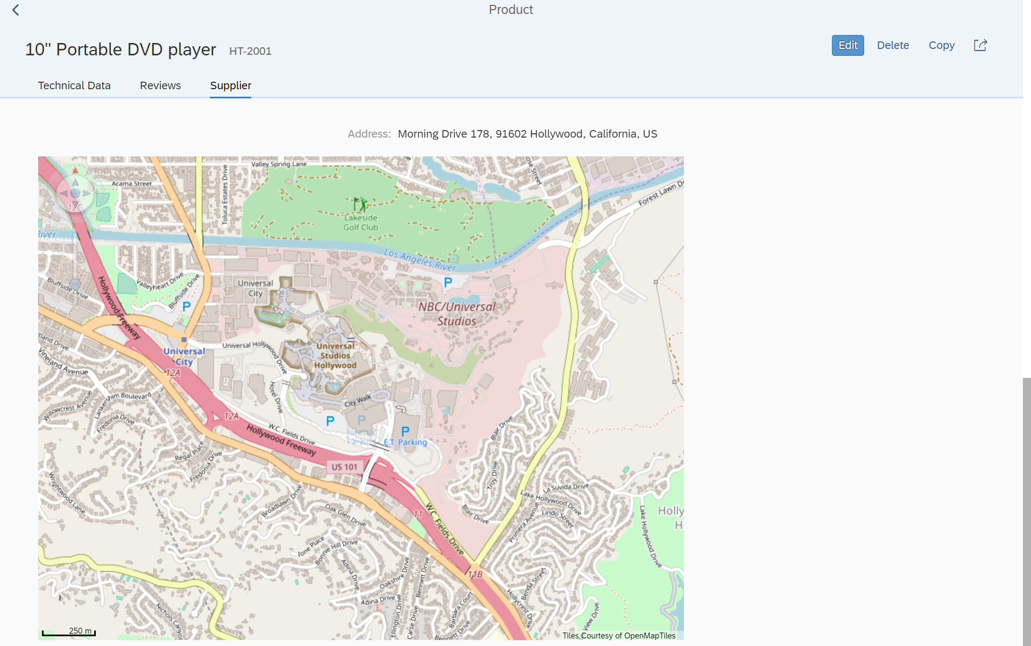

Related material
For more information on adaptation projects check out the following links:
- Documentation: SAPUI5 Visual Editor
- Documentation: Adaptation Projects for Fiori Elements Applications
- Demo Kit: Extending Delivered Apps Using Adaptation Extensions
- Demo Kit: Reusing UI Parts with Fragments
- Demo Kit: Using Controller Extension
- Demo Kit: Adaptation Extension Example: Adding a Button to the Table Toolbar in List Report
- Documentation: Deploy the App Variant
- Blog: Adaptation Projects - A Tutorial

